|  |  |
| --- | --- |
| **PAL**  **Detailed Design Document** | |
| **Summary** | This is the Software Detailed Design Document for the PAL component of *DAIMLER MMA* Project. |

|  |  |  |
| --- | --- | --- |
| **Author** | **Review** | **Approval** |
| SW Dev: Septimiu-Darex C. Vintila | See Project Master Document for the roles and Project Members List for the name of people | See Project Master Document for the roles and Project Members List for the name of people |
|  |  |  |
| **Distribution** | | |
| See Project Master Document for the roles and Project Members List for the name of people | See Project Master Document for the roles and Project Members List for the name of people | See Project Master Document for the roles and Project Members List for the name of people |

# Table of content

1.1. Revision history * 5

1.2. Purpose and Scope 5

1.3. Referenced documents 5

1.3.1. External documents 5

1.3.2. Internal Documents 5

1.4. Terminology and definitions 5

2.1. Overview 7

2.2. Traceability 7

3.1. Services 13

3.1.1. PAL_Init 13

3.1.2. PAL_runMainFunction 13

3.1.3. PAL_runReadMotorCurrentInmA 14

3.1.4. PAL_runReadMotorCurrentInA 15

3.1.5. PAL_runSetPowerOrder 16

3.1.6. PAL_runGetPWMOrder 17

3.1.7. PAL_StartFreeWheelingState 17

3.2. Auto-Tests 17

3.2.1. PAL_Autotest_CheckHWSelfProtection 17

3.2.2. PAL_Autotest_CheckMotorCurrent 18

3.2.3. PAL_Autotest_CheckMotorThermalProctection 19

3.2.4. PAL_Autotest_CheckCommandConsistency 20

3.2.5. PAL_Autotest_CheckMosfetLowSC 21

3.2.6. PAL_Autotest_CheckMosfetHighSC 22

3.2.7. PAL_Autotest_CheckMosfetOCAT 23

3.2.8. PAL_Autotest_CheckHighSideSwRegulation 24

3.2.9. PAL_Autotest_CheckMotorConnection 25

3.2.10. PAL_Autotest_CheckMotorPowerOrder 26

3.2.11. PAL_Autotest_CheckMotorDisengagement 27

3.2.12. PAL_Autotest_CheckMotorSC 28

3.3. Internal local functions 29

3.3.1. pal_bIsPowerStageInSelfProtection 29

3.3.2. pal_u8MotorCurrent_ManageMediumCurrentFailureDetection 30

3.3.3. pal_u8MotorCurrent_ManageHighCurrentFailureDetection 31

3.3.4. pal_AT_Init 32

3.3.5. pal_Cfg_Init 33

3.3.6. pal_ComputeCurrentHalfBridgeP 34

3.3.7. pal_ComputeCurrentHalfBridgeN 35

3.3.8. pal_StopMotorRotation 36

3.3.9. pal_DriveMotorInTensioning 36

3.3.10. pal_DriveMotorInReleasing 37

3.3.11. pal_DisablePowerStage 38

3.3.12. pal_u8MotorOrder_ManageMediumPWMFailureDetection 38

3.3.13. pal_u8MotorOrder_ManageHighPWMFailureDetection 39

3.3.14. pal_HighSideSWRegFreeWheelingPhase 40

3.3.15. pal_u8HighSideSWRegStep_1 41

3.3.16. pal_u8HighSideSWRegStep_2 41

3.4. Types 42

3.4.1. PAL_tHBridgeDefinition 42

3.4.2. PAL_tHBridgeCurrentValues 42

3.4.3. PAL_tBoostDriverDefinition 42

3.4.4. PAL_tFullBridgeDefinition 42

3.4.5. PAL_tPrelBoostTestData 43

3.4.6. PAL_tVBoostTestData 43

3.4.7. PAL_tAutoTestData 43

3.4.8. PAL_tTopologyConfiguration 44

3.5. Variables 44

3.5.1. PAL_kstHardWareTopology 44

3.5.2. PAL_u8RequestedMode 44

3.5.3. PAL_u8ModeState 44

3.5.4. PAL_u8FreeWheelingTimer 44

3.5.5. PAL_Cfg_InternalData 45

3.5.6. PAL_Cfg_AT_InternalData 45

3.6. Constants 45

3.6.1. PAL_CFG_TOPO_HBRIDGE_NB 45

3.6.2. PAL_CFG_KU8_HB_P_ID 45

3.6.3. PAL_CFG_KU8_HB_N_ID 45

3.6.4. PAL_CFG_TOPO_SHUNT_NB 45

3.6.5. PAL_CFG_TOPO_FULL_BRIDGE_NB 46

3.6.6. PAL_CFG_FREEWHEELING_TIME 46

3.6.7. PAL_CFG_PERIODIC_FCT_CALL 46

3.6.8. PAL_CFG_HIGH_LIMIT_LLD_CMD 46

3.6.9. PAL_CFG_DUTY_CYCLE_ADAPT_DEN 46

3.6.10. PAL_CFG_DUTY_CYCLE_ADAPT_ROUND 47

3.6.11. PAL_CFG_DUTY_CYCLE_ADAPT_A_NUM 47

3.6.12. PAL_CFG_DUTY_CYCLE_ADAPT_B_NUM 47

3.6.13. PAL_CFG_SLOPE_CTRL_MAX_VALUE 47

3.6.14. PAL_CFG_SLOPE_DEFAULT_VALUE 47

3.6.15. PAL_CFG_OFFSET_CTRL_MAX_VALUE 47

3.6.16. PAL_CFG_OFFSET_CTRL_MIN_VALUE 48

3.6.17. PAL_CFG_OFFSET_DEFAULT_VALUE 48

3.6.18. KU8_NB_INTERP_PTS_HB_CALIB 48

3.6.19. PAL_KU8_INIT_MODE_STATE 48

3.6.20. PAL_KU8_DIAGNOSTIC_MODE_STATE 48

3.6.21. PAL_KU8_IDLE_MODE_STATE 49

3.6.22. PAL_KU8_ACTIVATION_MODE_STATE 49

3.6.23. PAL_KU8_OFF_MODE_STATE 49

3.6.24. PAL_KU16_MAX_ADC_VALUE 49

3.6.25. PAL_KU16_MAX_ANALOG_CH_VALUE 49

3.6.26. PAL_KU16_DEFAULT_HW_SELF_PROT_THRS 49

3.6.27. PAL_KU32_CONVERT_A_TO_MA 50

3.6.28. PAL_KU8_PERIODICITY_10_MS 50

3.6.29. PAL_KU8_CONVERT_CENTIAMP_TO_MILLIAMP 50

3.6.30. PAL_S32_CONVERT_A_TO_MA 50

3.6.31. PAL_KU8_OCAT_PREPARE_STEP_1 50

3.6.32. PAL_KU8_OCAT_EXECUTE_STEP_1_PREPARE_STEP_2 51

3.6.33. PAL_KU8_OCAT_EXECUTE_STEP_2_PREPARE_STEP_3 51

3.6.34. PAL_KU8_OCAT_EXECUTE_STEP_3_PREPARE_STEP_4 51

3.6.35. PAL_KU8_OCAT_EXECUTE_STEP_4 51

3.6.36. PAL_KU8_EIGHTY 51

3.6.37. PAL_KU8_DIVIDE_BY_64_RIGHT_SHIFT 51

3.6.38. PAL_KU8_CONVERT_IN_PERCENT 52

3.6.39. PAL_KU32_CONVERT_MS_TO_100_MS 52

3.6.40. PAL_KU32_SIXTEEN 52

3.6.41. PAL_KU8_MOTOR_SHORT_CIRCUIT_RESITANCE_MIN_IDX 52

3.6.42. PAL_KU8_CONVERT_DUTY_CYCLE_TO_PWM_ORDER_FACTOR 52

3.6.43. PAL_KU8_HIGH_SIDE_SW_REG_INIT 53

3.6.44. PAL_KU8_HIGH_SIDE_SW_REG_ACTIVATION_STEP_1 53

3.6.45. PAL_KU8_HIGH_SIDE_SW_REG_ALGO_STEP_2 53

3.6.46. PAL_KU8_HIGH_SIDE_SW_REG_DEAD_TIME 53

3.6.47. PAL_KU8_HIGH_SIDE_SW_REG_FREE_WHEELING_PRESCALER 53

# Tables of figures

Figure 1: PAL_Init diagram 12

Figure 2: PAL_runMainFunction diagram 13

Figure 3: PAL_runReadMotorCurrentInmA diagram 14

Figure 4: PAL_runReadMotorCurrentInA diagram 14

Figure 5: PAL_runSetPowerOrder diagram 15

Figure 6: PAL_Autotest_CheckHWSelfProtection diagram 17

Figure 7: PAL_Autotest_CheckMotorCurrent diagram 18

Figure 8: PAL_Autotest_CheckMotorThermalProctection diagram 19

Figure 9 PAL_Autotest_CheckCommandConsistency 20

Figure 10 PAL_Autotest_CheckMosfetLowSC 21

Figure 11PAL_Autotest_CheckMosfetHighSC 22

Figure 12 PAL_Autotest_CheckMosfetOCAT 23

Figure 13 PAL_Autotest_CheckHighSideSwRegulation 24

Figure 14 PAL_Autotest_CheckMotorConnection 25

Figure 15 PAL_Autotest_CheckMotorPowerOrder 26

Figure 16 PAL_Autotest_CheckMotorDisengagement 27

Figure 17 PAL_Autotest_CheckMotorSC 28

Figure 18: pal_bIsPowerStageInSelfProtection diagram 29

Figure 19: pal_u8MotorCurrent_ManageMediumCurrentFailureDetection diagram 30

Figure 20: pal_u8MotorCurrent_ManageHighCurrentFailureDetection diagram 31

Figure 21: pal_AT_Init diagram 32

Figure 22: pal_Cfg_Init diagram 33

Figure 23: pal_ComputeCurrentHalfBridgeP diagram 34

Figure 24: pal_ComputeCurrentHalfBridgeN diagram 35

Figure 25: pal_StopMotorRotation diagram 35

Figure 26: pal_DriveMotorInTensioning diagram 36

Figure 27: pal_DriveMotorInReleasing diagram 37

Figure 28: pal_DisablePowerStage diagram 37

Figure 29 pal_u8MotorOrder_ManageMediumPWMFailureDetection 38

Figure 30 pal_u8MotorOrder_ManageHighPWMFailureDetection 39

# General Information

## Revision history *

|  |  |  |  |
| --- | --- | --- | --- |
| **Revision** | **Date** | **Author(s)** | **Description/comment** |
| 1.1.2.1 | 07.01.2022 | Septimiu-Darex C. Vintila | Initial revision. |
| 1.1.2.2 | 07.01.2022 | Septimiu-Darex C. Vintila | Services added. |
| 1.1.2.3 | 11.02.2022 | Septimiu-Darex C. Vintila | Corrections after review. |
| 1.1.2.4 | 29.03.2022 | Obada Mirela | Update traceabilty |
| 1.1.2.5 | 29.03.2022 | Obada Mirela | Update document |
| 1.1.2.6 | 11.04.2022 | Obada Mirela | Fix findings from review |
| 1.1.2.7 | 06.09.2022 | Madalina Serban | Added new functions and traceability |
| 1.1.2.8 | 08.09.2022 | Madalina Serban | Fixed review findings |
| 1.1.2.9 | 22.11.2022 | Mirela Obada | Add new req for tracebilty from arch |
| 1.1.2.10 | 10.02.2023 | Mirela Obada | Update document for 5.0 |
| 1.1.2.11 | 16.02.2023 | Mirela Obada | Update all diagrams and traceabilty for 5.0 |
| 1.1.2.12 | 16.02.2023 | Mirela Obada | Update 1 req for trasabilty |
| 1.1.2.13 | 17.02.2023 | Mirela Obada | Update 2 req for HSSwitch autotest |

*\* Template history is found in the CM tool used for templates*

## Purpose and Scope

The purpose of this document is to establish the functionality and behavior of the PAL component

## Referenced documents

### External documents

|  |  |  |
| --- | --- | --- |
| **Id** | **Title** | **Reference** |
|  |  |  |
|  |  |  |
|  |  |  |

### Internal Documents

|  |  |  |
| --- | --- | --- |
| **Id** | **Title** | **Reference** |
|  |  |  |
|  |  |  |
|  |  |  |
|  |  |  |

## Terminology and definitions

The generic acronyms are available in the [AEM process and method wiki](https://alvteams.alv.autoliv.int/sites/aeuaeequalityassurance/AEM%20Process%20wiki/acronyms.aspx)

|  |  |
| --- | --- |
| **Terminology** | **Meaning** |
| AAU | Atomic architectural unit |
| SW | software |
| PAL | Power Abstraction Layer |

# SW atomic architectural unit design

## Overview

The aim of the PAL module is to handle the interaction with the motor. The module controls the motor actions and also its self diagnostics.

The module is split in several files: PAL_Autotests.c, PAL_config.c, PAL_CurrentMeasure.c, PAL_main.c, PAL_PowerLayerDriving.c

## Traceability

|  |  |  |  |
| --- | --- | --- | --- |
| Requirements | Criteria | Linked Runnable | Source |
| DSG_PAL_0001 | The default value for the component Mode State shall be PAL_KU8_DIAGNOSTIC_MODE_STATE. | PAL_Init() | ARCH_SW_PAL_0010 |
| DSG_PAL_0002 | The default value for the component Requested Mode shall be PAL_KU8_INIT_MODE_STATE. | PAL_Init() | ARCH_SW_PAL_0010 |
| DSG_PAL_0003 | The default value for the counter Free Wheeling Timer shall be PAL_CFG_FREEWHEELING_TIME. | PAL_Init() | ARCH_SW_PAL_0010 |
| DSG_PAL_0004 | The configuration part of the component shall be initialized. | PAL_Init() | ARCH_SW_PAL_0010 |
| DSG_PAL_0005 | The component shall enable the H-Bridges related PWMs at start-up. | PAL_Init() | ARCH_SW_PAL_0010 |
| DSG_PAL_0006 | The running mode state of the component shall be evaluated every 2ms. | PAL_runMainFunction() | ARCH_SW_PAL_0450 |
| DSG_PAL_0007 | In case the running mode state is PAL_KU8_DIAGNOSTIC_MODE_STATE and the critical autotests are passed, the running mode state shall be set to PAL_KU8_IDLE_MODE_STATE. | PAL_runMainFunction() | ARCH_SW_PAL_0450; ARCH_SW_PAL_0457 |
| DSG_PAL_0008 | In case the running mode state is PAL_KU8_IDLE_MODE_STATE and a motor activation order has been received since the last function call, the running mode state shall be set to PAL_KU8_ACTIVATION_MODE_STATE. | PAL_runMainFunction() | ARCH_SW_PAL_0450 ARCH_SW_PAL_0457 |
| DSG_PAL_0009 | In case the running mode state is PAL_KU8_ACTIVATION_MODE_STATE and no motor activation order has been received since PAL_CFG_FREEWHEELING_TIME, the running mode state shall be set to PAL_KU8_IDLE_MODE_STATE. | PAL_runMainFunction() | ARCH_SW_PAL_0450 ARCH_SW_PAL_0457 |
| DSG_PAL_0010 | In case of Shut down request or in case of critical auto test have failed during startup phase, the running mode state shall be set to PAL_KU8_OFF_MODE_STATE. | PAL_runMainFunction() | ARCH_SW_PAL_0450; ARCH_SW_PAL_0456; ARCH_SW_PAL_0457 |
| DSG_PAL_0011 | The motor current shall be calculated based on the received motor power order. | PAL_runReadMotorCurrentInmA() PAL_runReadMotorCurrentInA() | ARCH_SW_PAL_0080; ARCH_SW_PAL_0100 |
| DSG_PAL_0012 | The motor current result shall be available in Amperes. | PAL_runReadMotorCurrentInA() | ARCH_SW_PAL_0100 |
| DSG_PAL_0013 | The motor current result shall be available in milliamperes. | PAL_runReadMotorCurrentInmA() | ARCH_SW_PAL_0080 |
| DSG_PAL_0014 | In case the motor is driven in tensioning direction, the motor current shall be calculated using Half Bridge P current. | PAL_runReadMotorCurrentInmA() PAL_runReadMotorCurrentInA() | ARCH_SW_PAL_0080; ARCH_SW_PAL_0100; ARCH_SW_PAL_0085; ARCH_SW_PAL_0105 |
| DSG_PAL_0015 | In case the motor is driven in tensioning direction, the motor current shall be calculated using Half Bridge N current. | PAL_runReadMotorCurrentInmA() PAL_runReadMotorCurrentInA() | ARCH_SW_PAL_0080; ARCH_SW_PAL_0100; ARCH_SW_PAL_0086; ARCH_SW_PAL_0106 |
| DSG_PAL_0016 | In case of a Null power order, the motor current shall be the sum of both Isense. | PAL_runReadMotorCurrentInmA() PAL_runReadMotorCurrentInA() | ARCH_SW_PAL_0080; ARCH_SW_PAL_0100; ARCH_SW_PAL_0085; ARCH_SW_PAL_0086; ARCH_SW_PAL_0105; ARCH_SW_PAL_0106 |
| DSG_PAL_0017 | The control of the motor power shall take place only in the modes allowed to control the power stage. | PAL_runSetPowerOrder() | ARCH_SW_PAL_0020; ARCH_SW_PAL_0025; ARCH_SW_PAL_0026; ARCH_SW_PAL_0027; ARCH_SW_PAL_0028; ARCH_SW_PAL_0029 |
| DSG_PAL_0018 | In case the absolute value of motor command is 0, the power layer shall be disabled. | PAL_runSetPowerOrder() | ARCH_SW_PAL_0020; ARCH_SW_PAL_0025; ARCH_SW_PAL_0026; ARCH_SW_PAL_0027; ARCH_SW_PAL_0028; ARCH_SW_PAL_0029 |
| DSG_PAL_0019 | In case the value of motor command has a negative value, the motor shall be driven in releasing direction. | PAL_runSetPowerOrder() | ARCH_SW_PAL_0020; ARCH_SW_PAL_0025; ARCH_SW_PAL_0026; ARCH_SW_PAL_0027; ARCH_SW_PAL_0028; ARCH_SW_PAL_0029 |
| DSG_PAL_0020 | In case the value of motor command has a positive value, the motor shall be driven in tensioning direction. | PAL_runSetPowerOrder() | ARCH_SW_PAL_0020; ARCH_SW_PAL_0025; ARCH_SW_PAL_0026; ARCH_SW_PAL_0027; ARCH_SW_PAL_0028; ARCH_SW_PAL_0029 |
| DSG_PAL_0021 | The Check HW Self Protection Autotest shall be executed every 10 ms. | PAL_Autotest_CheckHWSelfProtection() | ARCH_SW_PAL_0140 |
| DSG_PAL_0022 | If both the currents measured on the H-bridge of the Vp motor pin and the H-bridge of the Vn motor pin are below the current sense threshold, the Power Overvoltage Autotest shall return KU8_ATM_TEST_OK. | PAL_Autotest_CheckHWSelfProtection() | ARCH_SW_PAL_0140; ARCH_SW_PAL_0141; ARCH_SW_PAL_0145; ARCH_SW_PAL_0146 ARCH_SW_PAL_0147 |
| DSG_PAL_0023 | If the current measured on the H-bridge of the Vp motor pin is higher than the current sense threshold, the Power Overvoltage Autotest shall return KU8_ATM_TEST_NOK. | PAL_Autotest_CheckHWSelfProtection() | ARCH_SW_PAL_0140; ARCH_SW_PAL_0141; ARCH_SW_PAL_0145; ARCH_SW_PAL_0147 |
| DSG_PAL_0024 | If the current measured on the H-bridge of the Vn motor pin is higher than the current sense threshold, the Power Overvoltage Autotest shall return KU8_ATM_TEST_NOK. | PAL_Autotest_CheckHWSelfProtection() | ARCH_SW_PAL_0140; ARCH_SW_PAL_0141; ARCH_SW_PAL_0145; ARCH_SW_PAL_0146 |
| DSG_PAL_0025 | The Check Motor Current Autotest shall be executed every 10 ms. | PAL_AutotestCheckMotorCurrent() | ARCH_SW_PAL_0340 |
| DSG_PAL_0026 | In case a PRO cycle is running, the Check Motor Current Autotest shall return KU8_ATM_TEST_NOT_DECIDED. | PAL_AutotestCheckMotorCurrent() | ARCH_SW_PAL_0340 ARCH_SW_PAL_0342 |
| DSG_PAL_0027 | In case the executed cycle is a tensioning cycle and no medium current failure or high current failure was detected, the Check Motor Current Autotest shall return KU8_ATM_TEST_OK. | PAL_AutotestCheckMotorCurrent() | ARCH_SW_PAL_0340 ARCH_SW_PAL_0342 ARCH_SW_PAL_0345 |
| DSG_PAL_0028 | In case the executed cycle is a tensioning cycle and a medium current failure was detected, the Check Motor Current Autotest shall return KU8_ATM_TEST_NOK. | PAL_AutotestCheckMotorCurrent() | ARCH_SW_PAL_0340 ARCH_SW_PAL_0342 ARCH_SW_PAL_0345 |
| DSG_PAL_0029 | In case the executed cycle is a tensioning cycle and a high current failure was detected, the Check Motor Current Autotest shall return KU8_ATM_TEST_NOK. | PAL_AutotestCheckMotorCurrent() | ARCH_SW_PAL_0340 ARCH_SW_PAL_0342 ARCH_SW_PAL_0345 |
| DSG_PAL_0030 | In case the executed cycle is a tensioning cycle and one of medium current failure detection or high current failure detection could not be executed, the Check Motor Current Autotest shall return KU8_ATM_TEST_OK. | PAL_AutotestCheckMotorCurrent() | ARCH_SW_PAL_0340 ARCH_SW_PAL_0342 ARCH_SW_PAL_0345 |
| DSG_PAL_0031 | In case the executed cycle is a non-tensioning cycle and the time configured has not expired since the last KU8_ATM_TEST_NOK result, the Check Motor Current Autotest shall return KU8_ATM_TEST_NOK. | PAL_AutotestCheckMotorCurrent() | ARCH_SW_PAL_0340 ARCH_SW_PAL_0341 ARCH_SW_PAL_0342 ARCH_SW_PAL_0346 |
| DSG_PAL_0032 | In case the executed cycle is a non-tensioning cycle and the time configured has expired since the last KU8_ATM_TEST_NOK result, the Check Motor Current Autotest shall return KU8_ATM_TEST_OK. | PAL_AutotestCheckMotorCurrent() | ARCH_SW_PAL_0340 ARCH_SW_PAL_0341 ARCH_SW_PAL_0342 ARCH_SW_PAL_0346 |
| DSG_PAL_0033 | The Check Motor Thermal Protection Autotest shall be executed every 100 ms. | PAL_Autotest_CHeckMotorThermalProtection() | ARCH_SW_PAL_0360 |
| DSG_PAL_0034 | In case the previous Check Motor Thermal Protection Autotest result was KU8_ATM_TEST_NOK and the deficiency level is over the deskill threshold, the Check Motor Thermal Protection Autotest shall return KU8_ATM_TEST_NOK. | PAL_Autotest_CHeckMotorThermalProtection() | ARCH_SW_PAL_0360; ARCH_SW_PAL_0361; ARCH_SW_PAL_0365; ARCH_SW_PAL_0366; ARCH_SW_PAL_0367 |
| DSG_PAL_0035 | In case the previous Check Motor Thermal Protection Autotest result was KU8_ATM_TEST_NOK and the deficiency level is under the deskill threshold, the Check Motor Thermal Protection Autotest shall return KU8_ATM_TEST_OK. | PAL_Autotest_CHeckMotorThermalProtection() | ARCH_SW_PAL_0360; ARCH_SW_PAL_0361; ARCH_SW_PAL_0365;ARCH_SW_PAL_0366; ARCH_SW_PAL_0367 |
| DSG_PAL_0036 | In case the previous Check Motor Thermal Protection Autotest result was KU8_ATM_TEST_OK and the deficiency level is over the qualification threshold, the Check Motor Thermal Protection Autotest shall return KU8_ATM_TEST_NOK. | PAL_Autotest_CHeckMotorThermalProtection() | ARCH_SW_PAL_0360; ARCH_SW_PAL_0361; ARCH_SW_PAL_0365; ARCH_SW_PAL_0366; ARCH_SW_PAL_0367 |
| DSG_PAL_0037 | In case the previous Check Motor Thermal Protection Autotest result was KU8_ATM_TEST_OK and the deficiency level is under the qualification threshold, the Check Motor Thermal Protection Autotest shall return KU8_ATM_TEST_OK. | PAL_Autotest_CHeckMotorThermalProtection() | ARCH_SW_PAL_0360; ARCH_SW_PAL_0361; ARCH_SW_PAL_0365; ARCH_SW_PAL_0366; ARCH_SW_PAL_0367 |
| DSG_PAL_0038 | PAL component will initialize the module according to the project configuration | Requirement covered by PAL_Cfg_Init() function | ARCH_SW_PAL_0090,  ARCH_SW_PAL_0095 |
| DSG_PAL_0039 | PAL component will initialize the autotest internal data | Requirement covered by PAL_AT_Init() function | ARCH_SW_PAL_0110 |
| DSG_PAL_0040 | PAL component shall disable the HW when the motor is not activated | Requirement covered by PAL_DisablePowerStage() function | ARCH_SW_PAL_0070; ARCH_SW_PAL_0075; ARCH_SW_PAL_0076 |
| DSG_PAL_0041 | In case the power stage enable signals for the 2 half-bridge are consistent PAL_Autotest_CheckCommandConsistency autotest shall return KU8_ATM_TEST_OK | Requirement covered by PAL_Autotest_CheckCommandConsistency() function | ARCH_SW_PAL_0369; |
| DSG_PAL_0042 | In case the previous autotests for ADC, High Side SW, Driver command are not successfully executed, the autotest shall return KU8_ATM_TEST_NOT_DECIDED. | Requirement covered by PAL_Autotest_CheckMosfetLowSC() function | ARCH_SW_PAL_0370;ARCH_SW_PAL_0391;ARCH_SW_PAL_0390; |
| DSG_PAL_0043 | In case the voltage on either “Motor +” or “Motor – “pin drops bellow a certain threshold, the autotest shall return KU8_ATM_TEST_NOK | Requirement covered by PAL_Autotest_CheckMosfetLowSC() function | ARCH_SW_PAL_0370;ARCH_SW_PAL_0391;ARCH_SW_PAL_0390; |
| DSG_PAL_0044 | In case the previous autotests for ADC, High Side SW, Driver command return KU8_ATM_TEST_OK and the voltage on both pins is within the threshold, the autotest shall return KU8_ATM_TEST_OK | Requirement covered by PAL_Autotest_CheckMosfetLowSC() function | ARCH_SW_PAL_0370;ARCH_SW_PAL_0391;ARCH_SW_PAL_0390; |
| DSG_PAL_0045 | In case the previous autotests for ADC, High Side SW, Driver command are not successfully executed, the autotest shall return KU8_ATM_TEST_NOT_DECIDED. | Requirement covered by PAL_Autotest_CheckMosfetHighSC() function | ARCH_SW_PAL_0372; ARCH_SW_PAL_0395; ARCH_SW_PAL_0396; |
| DSG_PAL_0046 | In case the voltage on either “Motor +” or “Motor – “pin drops bellow a certain threshold, the autotest shall return KU8_ATM_TEST_NOK | Requirement covered by PAL_Autotest_CheckMosfetHighSC() function | ARCH_SW_PAL_0372; ARCH_SW_PAL_0395; ARCH_SW_PAL_0396; |
| DSG_PAL_0047 | In case the previous autotests for ADC, High Side SW, Driver command return KU8_ATM_TEST_OK and the voltage on both pins is within the threshold, the autotest shall return KU8_ATM_TEST_OK | Requirement covered by PAL_Autotest_CheckMosfetHighSC() function | ARCH_SW_PAL_0372; ARCH_SW_PAL_0395; ARCH_SW_PAL_0396; |
| DSG_PAL_0048 | In case the previous autotests for ADC, Driver Self protection, Motor Disconnection, Mosfet High Short Circuit, Mosfet Low Short Circuit, Driver command are not successfully executed, the autotest shall return KU8_ATM_TEST_NOT_DECIDED. | Requirement covered by PAL_Autotest_CheckMosfetOCAT() function | ARCH_SW_PAL_0374; ARCH_SW_PAL_0375; ARCH_SW_PAL_0373; |
| DSG_PAL_0049 | In case the computed voltage on either “Motor +” or “Motor – “pin passes over a certain threshold, the autotest shall return KU8_ATM_TEST_NOK | Requirement covered by PAL_Autotest_CheckMosfetOCAT() function | ARCH_SW_PAL_0374; ARCH_SW_PAL_0375; ARCH_SW_PAL_0373; |
| DSG_PAL_0050 | In case the previous autotests for ADC, Driver Self protection, Motor Disconnection, Mosfet High Short Circuit, Mosfet Low Short Circuit, Driver command return KU8_ATM_TEST_OK and the computed voltage from both pins are within a certain threshold, the autotest shall return KU8_ATM_TEST_OK | Requirement covered by PAL_Autotest_CheckMosfetOCAT() function | ARCH_SW_PAL_0374; ARCH_SW_PAL_0375; ARCH_SW_PAL_0373; |
| DSG_PAL_0051 | In case the previous autotests for ADC is not successfully executed, the autotest shall return KU8_ATM_TEST_NOT_DECIDED. | Requirement covered by PAL_Autotest_CheckHighSideSwRegulation() function | ARCH_SW_PAL_0368; |
| DSG_PAL_0052 | If High Side SW voltage is inside the functional range, return OK | Requirement covered by PAL_Autotest_CheckHighSideSwRegulation() function | ARCH_SW_PAL_0368; |
| DSG_PAL_0053 | If High Side SW voltage is not inside the functional range and maximum number of tries is reached, return NOK | Requirement covered by PAL_Autotest_CheckHighSideSwRegulation() function | ARCH_SW_PAL_0368; |
| DSG_PAL_0054 | In case the previous autotests for ADC, Mosfet High Short Circuit, Mosfet Low Short Circuit, High Side SW regulation are not successfully executed, the autotest shall return KU8_ATM_TEST_NOT_DECIDED. | Requirement covered by PAL_Autotest_CheckMotorConnection() function | ARCH_SW_PAL_0376; ARCH_SW_PAL_0377; ARCH_SW_PAL_0410; |
| DSG_PAL_0055 | In case the computed voltage difference between "Motor +" and "Motor -" goes over a certain threshold, the autotest shall return KU8_ATM_TEST_NOK | Requirement covered by PAL_Autotest_CheckMotorConnection() function | ARCH_SW_PAL_0376; ARCH_SW_PAL_0377; ARCH_SW_PAL_0410; |
| DSG_PAL_0056 | In case the battery is not stable during test execuction, the autotest shall return KU8_ATM_TEST_NOT_DECIDED. | Requirement covered by PAL_Autotest_CheckMotorConnection() function | ARCH_SW_PAL_0376; ARCH_SW_PAL_0377; ARCH_SW_PAL_0410; |
| DSG_PAL_0057 | In case the previous autotests for ADC, Mosfet High Short Circuit, Mosfet Low Short Circuit, High Side SW regulation return KU8_ATM_TEST_OK, the computed voltage difference between "Motor +" and "Motor -" are within a certain threshold and the battery is stable during the test, the autotest shall return KU8_ATM_TEST_OK | Requirement covered by PAL_Autotest_CheckMotorConnection() function | ARCH_SW_PAL_0376; ARCH_SW_PAL_0377; ARCH_SW_PAL_0410; |
| DSG_PAL_0058 | In case the previous autotests for ADC is not successfully executed and any PRO cycle is running, the autotest shall return KU8_ATM_TEST_NOT_DECIDED. | Requirement covered by PAL_Autotest_CheckMotorPowerOrder () function | ARCH_SW_PAL_0381; ARCH_SW_PAL_0382; ARCH_SW_PAL_0390; ARCH_SW_PAL_0391; ARCH_SW_PAL_0392; ARCH_SW_PAL_0393; |
| DSG_PAL_0059 | In case pal_u8MotorOrder_ManageMediumPWMFailureDetection or pal_u8MotorOrder_ManageHighPWMFailureDetection return KU8_ATM_TEST_NOK, the autotest shall return KU8_ATM_TEST_NOK. | Requirement covered by PAL_Autotest_CheckMotorPowerOrder () function | ARCH_SW_PAL_0381; ARCH_SW_PAL_0382; ARCH_SW_PAL_0390; ARCH_SW_PAL_0391; ARCH_SW_PAL_0392; |
| DSG_PAL_0060 | In case pal_u8MotorOrder_ManageMediumPWMFailureDetection or pal_u8MotorOrder_ManageHighPWMFailureDetection return KU8_ATM_TEST_OK, the autotest shall return KU8_ATM_TEST_OK. | Requirement covered by PAL_Autotest_CheckMotorPowerOrder () function | ARCH_SW_PAL_0381; ARCH_SW_PAL_0382; ARCH_SW_PAL_0390; ARCH_SW_PAL_0391; ARCH_SW_PAL_0392; |
| DSG_PAL_0061 | During any non tensioning cycles if there are any AECs qualified and the counter for motor order error is bellow a certain value, , the autotest shall return KU8_ATM_TEST_NOK. | Requirement covered by PAL_Autotest_CheckMotorPowerOrder () function | ARCH_SW_PAL_0381; ARCH_SW_PAL_0382; ARCH_SW_PAL_0390; ARCH_SW_PAL_0391; ARCH_SW_PAL_0392; |
| DSG_PAL_0070 | During any non tensioning cycles if there are no AECs qualified and al the counter for motor order error are set to zero, the autotest shall return KU8_ATM_TEST_OK. | Requirement covered by PAL_Autotest_CheckMotorPowerOrder () function | ARCH_SW_PAL_0381; ARCH_SW_PAL_0382; ARCH_SW_PAL_0390; ARCH_SW_PAL_0391; ARCH_SW_PAL_0392; |
| DSG_PAL_0063 | In case the previous autotests for ADC, Driver Self Protection are not successfully executed and any other cycles besides KU8_BELT_FUNCTION_29, KU8_BELT_FUNCTION_30, KU8_BELT_FUNCTION_31 are running, the autotest shall return KU8_ATM_TEST_NOT_DECIDED. | Requirement covered by PAL_Autotest_CheckMotorDisengagement() function | ARCH_SW_PAL_0378; ARCH_SW_PAL_0379; ARCH_SW_PAL_0380; ARCH_SW_PAL_0400; ARCH_SW_PAL_0401; ARCH_SW_PAL_0402; ARCH_SW_PAL_0403; |
| DSG_PAL_0062 | In case the motor current is above the threshold, and the counter for maximum failed occurrences reaches the maximum number of failures, the autotest shall return KU8_ATM_TEST_NOK and the motor blocked counter is reset to zero. | Requirement covered by PAL_Autotest_CheckMotorDisengagement() function | ARCH_SW_PAL_0378; ARCH_SW_PAL_0379; ARCH_SW_PAL_0380; ARCH_SW_PAL_0400; ARCH_SW_PAL_0401; ARCH_SW_PAL_0402; ARCH_SW_PAL_0403; |
| DSG_PAL_0069 | In case the motor currebt is bellow the threshold and the couter for maximum passed occurences is reached, autotest shall return KU8_ATM_TEST_OK and the counter is reset to zero. | Requirement covered by PAL_Autotest_CheckMotorDisengagement() function | ARCH_SW_PAL_0378; ARCH_SW_PAL_0379; ARCH_SW_PAL_0380; ARCH_SW_PAL_0400; ARCH_SW_PAL_0401; ARCH_SW_PAL_0402; ARCH_SW_PAL_0403; |
| DSG_PAL_0064 | In case MOSFET Short Circuit OR ADC OR HW Self protection auto-tests results are failed or no releasing cycle is executed, the autotest shall return KU8_ATM_TEST_NOT_DECIDED. | Requirement covered by PAL_Autotest_CheckMotorSC() function | ARCH_SW_PAL_0383; ARCH_SW_PAL_0384; ARCH_SW_PAL_0385; ARCH_SW_PAL_0386; ARCH_SW_PAL_0387; ARCH_SW_PAL_0388;ARCH_SW_PAL_0389; |
| DSG_PAL_0065 | In case the measured Motor current is higher than the calculated current threshold and if the filter counter has reach the failed threshold, the autotest shall return KU8_ATM_TEST_NOK and the counter is reset to zero. | Requirement covered by PAL_Autotest_CheckMotorSC() function | ARCH_SW_PAL_0383; ARCH_SW_PAL_0384; ARCH_SW_PAL_0385; ARCH_SW_PAL_0386; ARCH_SW_PAL_0387; ARCH_SW_PAL_0388;ARCH_SW_PAL_0389; |
| DSG_PAL_0066 | In case the measured Motor current is below the calculated current threshold and the filter ccounter has not reached the passed threshold, the autotest shall return KU8_ATM_TEST_NOK and the counter is incremented to 1. | Requirement covered by PAL_Autotest_CheckMotorSC() function | ARCH_SW_PAL_0383; ARCH_SW_PAL_0384; ARCH_SW_PAL_0385; ARCH_SW_PAL_0386; ARCH_SW_PAL_0387; ARCH_SW_PAL_0388;ARCH_SW_PAL_0389; |
| DSG_PAL_0067 | In case the measured Motor current is below the calculated current threshold and the filter ccounter has reached the passed threshold, the autotest shall return KU8_ATM_TEST_OK and the counter is reset to 0. | Requirement covered by PAL_Autotest_CheckMotorSC() function | ARCH_SW_PAL_0383; ARCH_SW_PAL_0384; ARCH_SW_PAL_0385; ARCH_SW_PAL_0386; ARCH_SW_PAL_0387; ARCH_SW_PAL_0388;ARCH_SW_PAL_0389; |
| DSG_PAL_0068 | In case the absolute physical value of motor current is bellow the specified threshold, autotest shall return KU8_ATM_TEST_OK. | Requirement covered by PAL_Autotest_CheckMotorSC() function | ARCH_SW_PAL_0383; ARCH_SW_PAL_0384; ARCH_SW_PAL_0385; ARCH_SW_PAL_0386; ARCH_SW_PAL_0387; ARCH_SW_PAL_0388;ARCH_SW_PAL_0389 |
| DSG_PAL_0069 | The value of the power stage shall be set and available to the rest of application. | PAL_StartFreeWheelingState() | ARCH_SW_PAL_0077; ARCH_SW_PAL_0078; ARCH_SW_PAL_0079; |

# FEATURES

## Services

### PAL_Init

|  |  |  |
| --- | --- | --- |
| **Object :** | | |
| This function shall initialize the PAL SW unit. | | |
| **Input Parameters :** | | |
| Name | Type | Description |
| none |  |  |
| **Output Parameters f** | | |
| Name | Type | Description |
| none |  |  |
| **Dynamic Aspect :** | | |
| Will be called at system startup | | |
| Who : | Scheduler | |
| **Return value :** | | |
| Type : | Description | |
| none | - | |
| **Constraints :** | | |
| none | | |
| **Static aspect :** | | |
|  | | |

Figure : PAL_Init diagram

### PAL_runMainFunction

|  |  |  |
| --- | --- | --- |
| **Object :** | | |
| Cyclic runnable in charge of the internal state machine. Handles freewheeling timer and disabling power stage. | | |
| **Input Parameters :** | | |
| Name | Type | Description |
| none |  |  |
| **Output Parameters :** | | |
| Name | Type | Description |
| none |  |  |
| **Dynamic Aspect :** | | |
| Will be called at 2 ms | | |
| Who : | Scheduler | |
| **Return value :** | | |
| Type : | Description | |
| none |  | |
| **Constraints :** | | |
| none | | |
| **Static aspect :** | | |
|  | | |

Figure : PAL_runMainFunction diagram

### PAL_runReadMotorCurrentInmA

|  |  |  |
| --- | --- | --- |
| **Object :** | | |
| Function that provides the current in Milli Ampere | | |
| **Input Parameters :** | | |
| Name | Type | Description |
| none |  |  |
| **Output Parameters :** | | |
| Name | Type | Description |
| ps32MotorCurrentInmA | s32MotorCurrentInmAType | Pointer used to store the requested result |
| **Dynamic Aspect :** | | |
| Called on request | | |
| Who : | BFE | |
| **Return value :** | | |
| Type : | Description | |
| none |  | |
| **Constraints :** | | |
| none | | |
| **Static aspect :** | | |
|  | | |

Figure : PAL_runReadMotorCurrentInmA diagram

### PAL_runReadMotorCurrentInA

|  |  |  |
| --- | --- | --- |
| **Object :** | | |
| Function that provides the current in Ampere | | |
| **Input Parameters :** | | |
| Name | Type | Description |
| none |  |  |
| **Output Parameters :** | | |
| Name | Type | Description |
| ps8MotorCurrentInA | s8MotorCurrentInAType | Pointer used to store the requested result |
| **Dynamic Aspect :** | | |
| Called on request | | |
| Who : | BFE, PMP | |
| **Return value :** | | |
| Type : | Description | |
| none |  | |
| **Constraints :** | | |
| none | | |
| **Static aspect :** | | |
|  | | |

Figure : PAL_runReadMotorCurrentInA diagram

### PAL_runSetPowerOrder

|  |  |  |
| --- | --- | --- |
| **Object :** | | |
| External service called by upper layer in order to drive the motor in case of belt function activation | | |
| **Input Parameters :** | | |
| Name | Type | Description |
| s16MotorPowerOrder | s16MotorPowerOrderType | Requested motor power order |
| u16BoostDutyCycle | u16BoostPWMOrderType | Requested Duty Cycle |
| **Output Parameters :** | | |
| Name | Type | Description |
| ps8MotorCurrentInA | s8MotorCurrentInAType | Pointer used to store the requested result |
| **Dynamic Aspect :** | | |
| Called on request | | |
| Who : | BFE | |
| **Return value :** | | |
| Type : | Description | |
| none |  | |
| **Constraints :** | | |
| none | | |
| **Static aspect :** | | |
|  | | |

Figure : PAL_runSetPowerOrder diagram

### PAL_runGetPWMOrder

|  |  |  |
| --- | --- | --- |
| Object | | |
| This function shall provide the current applied power order. | | |
| **Prototype** | | |
| EXPORTED void PAL_runGetPWMOrder (s16MotorPowerOrderType *ps16MotorPowerOrder) | | |
| **Input parameters** | | |
| Name | Type | Description |
| NA | NA | NA |
| **Output parameters** | | |
| Name | Type | Description |
| ps16MotorPowerOrder | s16MotorPowerOrderType* | Applied motor power order |
| **Return value** | | |
| Type | Description | |
| NA | - | |
| **Dynamic aspect** | | |
| Who(callers) | Description | |
| * | * | |
| **Static aspect** | | |
|  | | |
| **Constrains** | | |
|  | | |
|  |  |  |

### PAL_StartFreeWheelingState

|  |  |  |
| --- | --- | --- |
| Object | | |
| This function shall set the power H-bridge in free-wheeling state. | | |
| **Prototype** | | |
| EXPORTED void PAL_StartFreeWheelingState (void) | | |
| **Input parameters** | | |
| Name | Type | Description |
| NA | NA | NA |
| **Output parameters** | | |
| Name | Type | Description |
| NA | NA | NA |
| **Return value** | | |
| Type | Description | |
| NA | - | |
| **Dynamic aspect** | | |
| Who(callers) | Description | |
| * | * | |
| **Static aspect** | | |
|  | | |

## Auto-Tests

### PAL_Autotest_CheckHWSelfProtection

|  |  |  |
| --- | --- | --- |
| **Object :** | | |
| This function has to test the Hardware self-protection on Half Bridges | | |
| **Input Parameters :** | | |
| Name | Type | Description |
| none |  |  |
| **Output Parameters :** | | |
| Name | Type | Description |
| pu8TestResult | u8TestResultType | Pointer used to store the auto test result |
| **Dynamic Aspect :** | | |
| Called on request | | |
| Who : | MMG | |
| **Return value :** | | |
| Type : | Description | |
| none |  | |
| **Constraints :** | | |
| none | | |
| **Static aspect :** | | |
|  | | |

Figure : PAL_Autotest_CheckHWSelfProtection diagram

### PAL_Autotest_CheckMotorCurrent

|  |  |  |
| --- | --- | --- |
| **Object :** | | |
| This function has to test that a high motor current will not be applied for a too long time (scope is to protect motor and HW components) | | |
| **Input Parameters :** | | |
| Name | Type | Description |
| none |  |  |
| **Output Parameters :** | | |
| Name | Type | Description |
| pu8TestResult | u8TestResultType | Pointer used to store the auto test result |
| **Dynamic Aspect :** | | |
| Called on request | | |
| Who : | MMG | |
| **Return value :** | | |
| Type : | Description | |
| none |  | |
| **Constraints :** | | |
| none | | |
| **Static aspect :** | | |
|  | | |

Figure : PAL_Autotest_CheckMotorCurrent diagram

### PAL_Autotest_CheckMotorThermalProctection

|  |  |  |
| --- | --- | --- |
| **Object :** | | |
| This function has to test that the motor is not too hot (high temperature will damage the motor and the electronic) | | |
| **Input Parameters :** | | |
| Name | Type | Description |
| none |  |  |
| **Output Parameters :** | | |
| Name | Type | Description |
| pu8TestResult | u8TestResultType | Pointer used to store the auto test result |
| **Dynamic Aspect :** | | |
| Called on request | | |
| Who : | MMG | |
| **Return value :** | | |
| Type : | Description | |
| none |  | |
| **Constraints :** | | |
| none | | |
| **Static aspect :** | | |
|  | | |

Figure : PAL_Autotest_CheckMotorThermalProctection diagram

### PAL_Autotest_CheckCommandConsistency

|  |  |  |
| --- | --- | --- |
| Object | | |
| This function shall indicate if the power stage activation state is consistent with the order. | | |
| **Prototype** | | |
| void PAL_Autotest_CheckCommandConsistency (u8TestResultType *pu8TestResult) | | |
| **Input parameters** | | |
| Name | Type | Description |
| NA | NA | NA |
| **Output parameters** | | |
| Name | Type | Description |
| pu8TestResult | u8TestResultType* | Status of the test |
| **Return value** | | |
| Type | Description | |
| NA | - | |
| **Dynamic aspect** | | |
| Who(callers) | Description | |
| * | * | |
| **Static aspect** | | |
|  | | |
| **Constrains** | | |
|  | | |
|  |  |  |
|  |  |  |

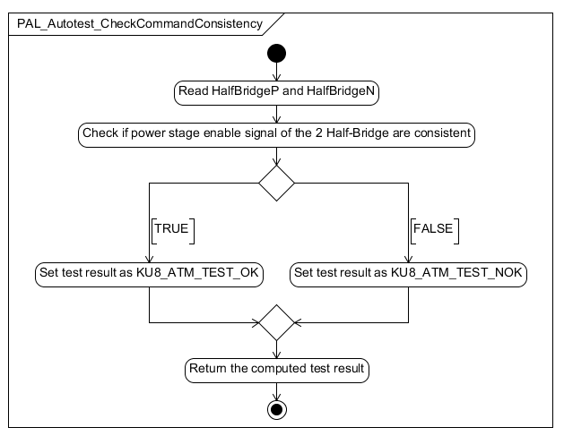

Figure PAL_Autotest_CheckCommandConsistency

### PAL_Autotest_CheckMosfetLowSC

|  |  |  |
| --- | --- | --- |
| Object | | |
| This function shall test if the low MOFSET of the power bridge are in short circuit. | | |
| **Prototype** | | |
| void PAL_Autotest_CheckMosfetLowSC (u8TestResultType *pu8TestResult) | | |
| **Input parameters** | | |
| Name | Type | Description |
| NA | NA | NA |
| **Output parameters** | | |
| Name | Type | Description |
| pu8TestResult | u8TestResultType* | Status of the test |
| **Return value** | | |
| Type | Description | |
| NA | - | |
| **Dynamic aspect** | | |
| Who(callers) | Description | |
| * | * | |
| **Static aspect** | | |
|  | | |
| **Constrains** | | |
|  | | |
|  |  |  |
|  |  |  |

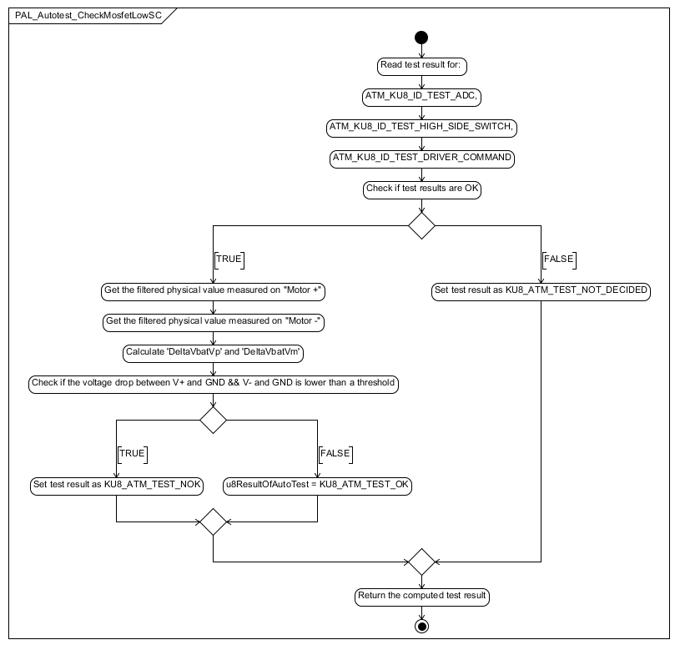

Figure PAL_Autotest_CheckMosfetLowSC

### PAL_Autotest_CheckMosfetHighSC

|  |  |  |
| --- | --- | --- |
| Object | | |
| This function shall test if the high MOFSET of the power bridge are in short circuit. | | |
| **Prototype** | | |
| void PAL_Autotest_CheckMosfetHighSC (u8TestResultType *pu8TestResult) | | |
| **Input parameters** | | |
| Name | Type | Description |
| NA | NA | NA |
| **Output parameters** | | |
| Name | Type | Description |
| pu8TestResult | u8TestResultType* | Status of the test |
| **Return value** | | |
| Type | Description | |
| NA | - | |
| **Dynamic aspect** | | |
| Who(callers) | Description | |
| * | * | |
| **Static aspect** | | |
|  | | |
| **Constrains** | | |
|  | | |
|  |  |  |
|  |  |  |

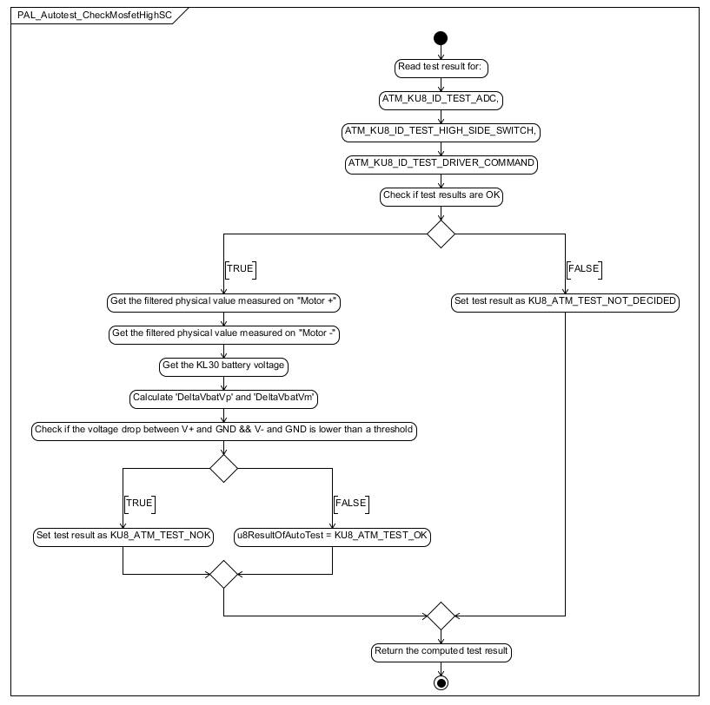

Figure PAL_Autotest_CheckMosfetHighSC

### PAL_Autotest_CheckMosfetOCAT

|  |  |  |
| --- | --- | --- |
| Object | | |
| This function shall test if MOFSET of the power bridge stay in open circuit when ordered | | |
| **Prototype** | | |
| void PAL_Autotest_CheckMosfetOCAT (u8TestResultType *pu8TestResult) | | |
| **Input parameters** | | |
| Name | Type | Description |
| NA | NA | NA |
| **Output parameters** | | |
| Name | Type | Description |
| pu8TestResult | u8TestResultType* | Status of the test |
| **Return value** | | |
| Type | Description | |
| NA | - | |
| **Dynamic aspect** | | |
| Who(callers) | Description | |
| * | * | |
| **Static aspect** | | |
|  | | |
| **Constrains** | | |
|  | | |
|  |  |  |
|  |  |  |

Figure PAL_Autotest_CheckMosfetOCAT

### PAL_Autotest_CheckHighSideSwRegulation

|  |  |  |
| --- | --- | --- |
| Object | | |
| This function shall checkif high switch regulation works well. | | |
| **Prototype** | | |
| void PAL_Autotest_CheckHighSideSwRegulation (u8TestResultType *pu8TestResult) | | |
| **Input parameters** | | |
| Name | Type | Description |
| NA | NA | NA |
| **Output parameters** | | |
| Name | Type | Description |
| pu8TestResult | u8TestResultType* | Status of the test |
| **Return value** | | |
| Type | Description | |
| NA | - | |
| **Dynamic aspect** | | |
| Who(callers) | Description | |
| * | * | |
| **Static aspect** | | |
|  | | |
| **Constrains** | | |
|  | | |
|  |  |  |
|  |  |  |

Figure PAL_Autotest_CheckHighSideSwRegulation

### PAL_Autotest_CheckMotorConnection

|  |  |  |
| --- | --- | --- |
| Object | | |
| This function shall test if the motor is well connected | | |
| **Prototype** | | |
| void PAL_Autotest_CheckMotorConnection (u8TestResultType *pu8TestResult) | | |
| **Input parameters** | | |
| Name | Type | Description |
| NA | NA | NA |
| **Output parameters** | | |
| Name | Type | Description |
| pu8TestResult | u8TestResultType* | Status of the test |
| **Return value** | | |
| Type | Description | |
| NA | - | |
| **Dynamic aspect** | | |
| Who(callers) | Description | |
| * | * | |
| **Static aspect** | | |
|  | | |
| **Constrains** | | |
|  | | |
|  |  |  |
|  |  |  |

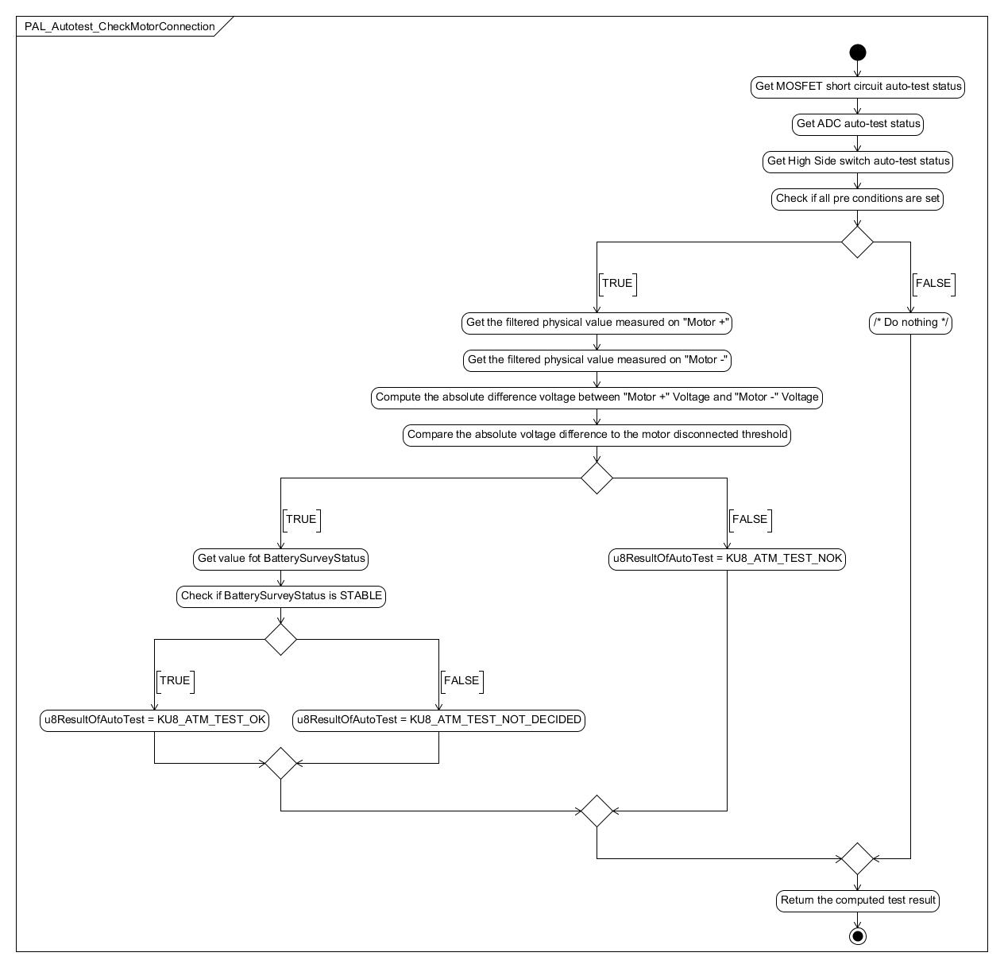

Figure PAL_Autotest_CheckMotorConnection

### PAL_Autotest_CheckMotorPowerOrder

|  |  |  |
| --- | --- | --- |
| Object | | |
| This function shall check if the PWM order is greater than 2 different thresholds during a specified time | | |
| **Prototype** | | |
| void PAL_Autotest_CheckMotorPowerOrder (u8TestResultType *pu8TestResult) | | |
| **Input parameters** | | |
| Name | Type | Description |
| NA | NA | NA |
| **Output parameters** | | |
| Name | Type | Description |
| pu8TestResult | u8TestResultType* | Status of the test |
| **Return value** | | |
| Type | Description | |
| NA | - | |
| **Dynamic aspect** | | |
| Who(callers) | Description | |
| * | * | |
| **Static aspect** | | |
|  | | |
| **Constrains** | | |
|  | | |

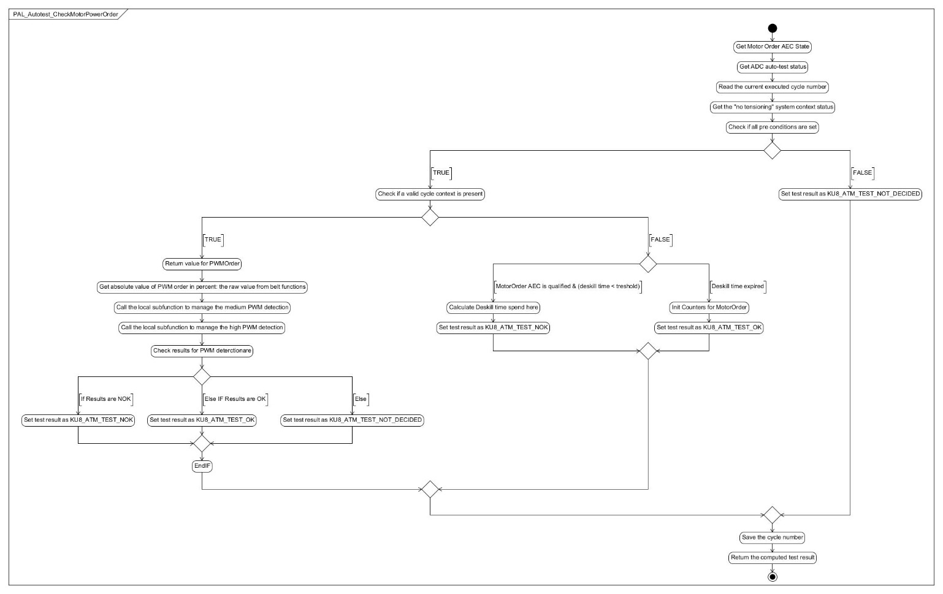

Figure PAL_Autotest_CheckMotorPowerOrder

### PAL_Autotest_CheckMotorDisengagement

|  |  |  |
| --- | --- | --- |
| Object | | |
| This function shall check whether the motor is blocked while performing a releasing mode | | |
| **Prototype** | | |
| void PAL_Autotest_CheckMotorDisengagement (u8TestResultType *pu8TestResult) | | |
| **Input parameters** | | |
| Name | Type | Description |
| NA | NA | NA |
| **Output parameters** | | |
| Name | Type | Description |
| pu8TestResult | u8TestResultType* | Status of the test |
| **Return value** | | |
| Type | Description | |
| NA | - | |
| **Dynamic aspect** | | |
| Who(callers) | Description | |
| * | * | |
| **Static aspect** | | |
|  | | |
| **Constrains** | | |
|  | | |
|  |  |  |
|  |  |  |

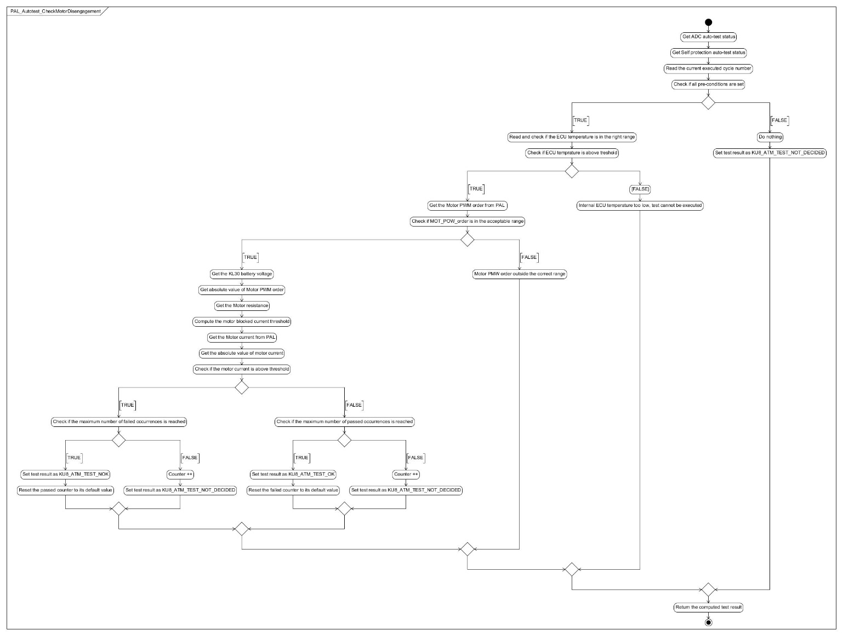

Figure PAL_Autotest_CheckMotorDisengagement

### PAL_Autotest_CheckMotorSC

|  |  |  |
| --- | --- | --- |
| Object | | |
| This function shall check if the motor is in short circuit during a start-up release cycle | | |
| **Prototype** | | |
| void PAL_Autotest_CheckMotorSC (u8TestResultType *pu8TestResult) | | |
| **Input parameters** | | |
| Name | Type | Description |
| NA | NA | NA |
| **Output parameters** | | |
| Name | Type | Description |
| pu8TestResult | u8TestResultType* | Status of the test |
| **Return value** | | |
| Type | Description | |
| NA | - | |
| **Dynamic aspect** | | |
| Who(callers) | Description | |
| * | * | |
| **Static aspect** | | |
|  | | |
| **Constrains** | | |
|  | | |
|  |  |  |
|  |  |  |

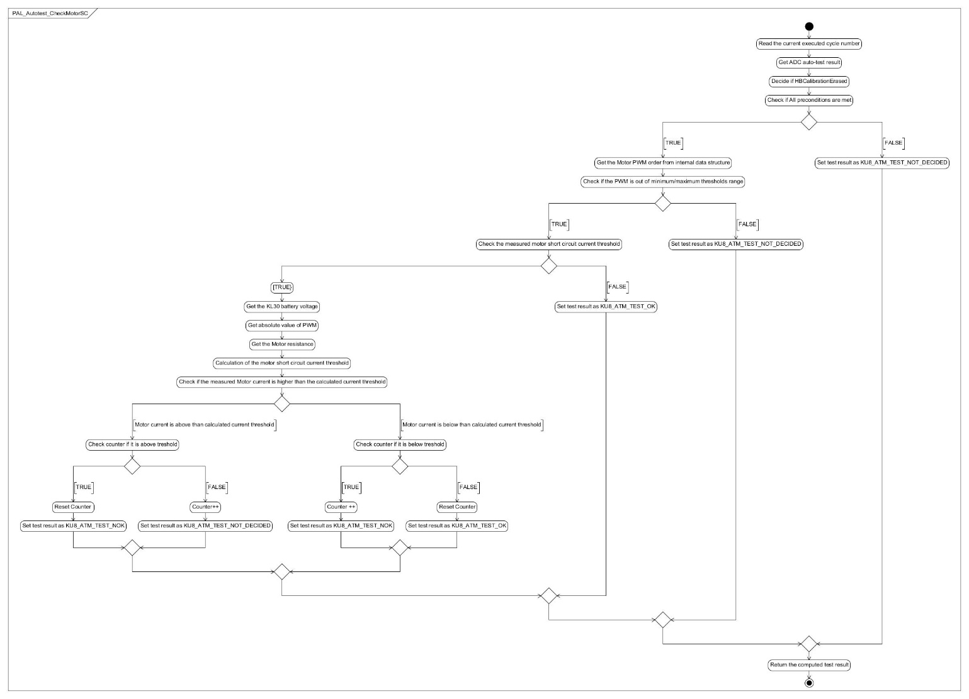

Figure PAL_Autotest_CheckMotorSC

## Internal local functions

### pal_bIsPowerStageInSelfProtection

|  |  |  |
| --- | --- | --- |
| **Object :** | | |
| This function aims at detect the HW self-protection | | |
| **Input Parameters :** | | |
| Name | Type | Description |
| none |  |  |
| **Output Parameters :** | | |
| Name | Type | Description |
| none |  |  |
| **Dynamic Aspect :** | | |
| Called on request | | |
| Who : | PAL_Autotest_CheckHWSelfProtection() | |
| **Return value :** | | |
| Type : | Description | |
| boolean | The result value on uint8 with the ATM return value format  B_TRUE : Self-protection detected  B_FALSE: No self-protection detected | |
| **Constraints :** | | |
| none | | |
| **Static aspect :** | | |
|  | | |

Figure : pal_bIsPowerStageInSelfProtection diagram

### pal_u8MotorCurrent_ManageMediumCurrentFailureDetection

|  |  |  |
| --- | --- | --- |
| **Object :** | | |
| This function aims at manage a time counter and a reset counter to detect if the motor has been over a "medium current threshold" for more than the associated "medium current time threshold", since the last time the motor current was continuously under or equal to the "medium current threshold" for a "medium current reset time threshold". | | |
| **Input Parameters :** | | |
| Name | Type | Description |
| cu32PhysicalMotorCurrent_mA | const uint32 | Physical Motor Current in mA |
| **Output Parameters :** | | |
| Name | Type | Description |
| none |  |  |
| **Dynamic Aspect :** | | |
| Called on request | | |
| Who : | PAL_Autotest_CheckMotorCurrent() | |
| **Return value :** | | |
| Type : | Description | |
| uint8 | The result value on uint8 with the ATM return value format  ATM_U8_NOK: failure detected  ATM_U8_NOT_DECIDED: no failure detected | |
| **Constraints :** | | |
| none | | |
| **Static aspect :** | | |
|  | | |

Figure : pal_u8MotorCurrent_ManageMediumCurrentFailureDetection diagram

### pal_u8MotorCurrent_ManageHighCurrentFailureDetection

|  |  |  |
| --- | --- | --- |
| **Object :** | | |
| This function aims at manage a time counter and a reset counter to detect if the motor has been over a "high current threshold" for more than the associated "high current time threshold", since the last time the motor current was continuously under or equal to the "high current threshold" for a "high current reset time threshold". | | |
| **Input Parameters :** | | |
| Name | Type | Description |
| cu32PhysicalMotorCurrent_mA | const uint32 | Physical Motor Current in mA |
| **Output Parameters :** | | |
| Name | Type | Description |
| none |  |  |
| **Dynamic Aspect :** | | |
| Called on request | | |
| Who : | PAL_Autotest_CheckMotorCurrent() | |
| **Return value :** | | |
| Type : | Description | |
| uint8 | The result value on uint8 with the ATM return value format  ATM_U8_NOK: failure detected  ATM_U8_NOT_DECIDED: no failure detected | |
| **Constraints :** | | |
| none | | |
| **Static aspect :** | | |
|  | | |

Figure : pal_u8MotorCurrent_ManageHighCurrentFailureDetection diagram

### pal_AT_Init

|  |  |  |
| --- | --- | --- |
| **Object :** | | |
| This function initializes all static data used during PAL auto tests. | | |
| **Input Parameters :** | | |
| Name | Type | Description |
| none |  |  |
| **Output Parameters :** | | |
| Name | Type | Description |
| none |  |  |
| **Dynamic Aspect :** | | |
| Called on request | | |
| Who : | pal_Cfg_Init() | |
| **Return value :** | | |
| Type : | Description | |
| none |  | |
| **Constraints :** | | |
| none | | |
| **Static aspect :** | | |
|  | | |

Figure : pal_AT_Init diagram

### pal_Cfg_Init

|  |  |  |
| --- | --- | --- |
| **Object :** | | |
| Initialization function for the configuration | | |
| **Input Parameters :** | | |
| Name | Type | Description |
| none |  |  |
| **Output Parameters :** | | |
| Name | Type | Description |
| none |  |  |
| **Dynamic Aspect :** | | |
| Called on request | | |
| Who : | PAL_Init() | |
| **Return value :** | | |
| Type : | Description | |
| none |  | |
| **Constraints :** | | |
| none | | |
| **Static aspect :** | | |
|  | | |

Figure : pal_Cfg_Init diagram

### pal_ComputeCurrentHalfBridgeP

|  |  |  |
| --- | --- | --- |
| **Object :** | | |
| Function that provides the current in Milli Ampere for Half Bridge P | | |
| **Input Parameters :** | | |
| Name | Type | Description |
| none |  |  |
| **Output Parameters :** | | |
| Name | Type | Description |
| ps32MeasuredCurrent | sint32 * const | Measured current in mA |
| **Dynamic Aspect :** | | |
| Called on request | | |
| Who : | PAL_runReadMotorCurrentInmA() | |
| **Return value :** | | |
| Type : | Description | |
| none |  | |
| **Constraints :** | | |
| none | | |
| **Static aspect :** | | |
|  | | |

Figure : pal_ComputeCurrentHalfBridgeP diagram

### pal_ComputeCurrentHalfBridgeN

|  |  |  |
| --- | --- | --- |
| **Object :** | | |
| Function that provides the current in Milli Ampere for HN | | |
| **Input Parameters :** | | |
| Name | Type | Description |
| none |  |  |
| **Output Parameters :** | | |
| Name | Type | Description |
| ps32MeasuredCurrent | sint32 * const | Measured current in mA |
| **Dynamic Aspect :** | | |
| Called on request | | |
| Who : | PAL_runReadMotorCurrentInmA() | |
| **Return value :** | | |
| Type : | Description | |
| none |  | |
| **Constraints :** | | |
| none | | |
| **Static aspect :** | | |
|  | | |

Figure : pal_ComputeCurrentHalfBridgeN diagram

### pal_StopMotorRotation

|  |  |  |
| --- | --- | --- |
| **Object :** | | |
| Function used to stop the motor rotation | | |
| **Input Parameters :** | | |
| Name | Type | Description |
| none |  |  |
| **Output Parameters :** | | |
| Name | Type | Description |
| none |  |  |
| **Dynamic Aspect :** | | |
| Called on request | | |
| Who : | PAL_runSetPowerOrder() | |
| **Return value :** | | |
| Type : | Description | |
| none |  | |
| **Constraints :** | | |
| none | | |
| **Static aspect :** | | |
|  | | |

Figure : pal_StopMotorRotation diagram

### pal_DriveMotorInTensioning

|  |  |  |
| --- | --- | --- |
| **Object :** | | |
| Function used to drive the motor in tensioning direction | | |
| **Input Parameters :** | | |
| Name | Type | Description |
| cu16AbsoluteMotorCommand | const uint16 | Motor command |
| cu16BoosterMotorCommand | const uint16 | Motor booster command |
| **Output Parameters :** | | |
| Name | Type | Description |
| none |  |  |
| **Dynamic Aspect :** | | |
| Called on request | | |
| Who : | PAL_runSetPowerOrder() | |
| **Return value :** | | |
| Type : | Description | |
| none |  | |
| **Constraints :** | | |
| none | | |
| **Static aspect :** | | |
|  | | |

Figure : pal_DriveMotorInTensioning diagram

### pal_DriveMotorInReleasing

|  |  |  |
| --- | --- | --- |
| **Object :** | | |
| Function used to drive the motor in releasing direction | | |
| **Input Parameters :** | | |
| Name | Type | Description |
| cu16AbsoluteMotorCommand | const uint16 | Motor command |
| **Output Parameters :** | | |
| Name | Type | Description |
| none |  |  |
| **Dynamic Aspect :** | | |
| Called on request | | |
| Who : | PAL_runSetPowerOrder() | |
| **Return value :** | | |
| Type : | Description | |
| none |  | |
| **Constraints :** | | |
| none | | |
| **Static aspect :** | | |
|  | | |

Figure : pal_DriveMotorInReleasing diagram

### pal_DisablePowerStage

|  |  |  |
| --- | --- | --- |
| **Object :** | | |
| External service that will disable the HW components that drive the motor | | |
| **Input Parameters :** | | |
| Name | Type | Description |
| none |  |  |
| **Output Parameters :** | | |
| Name | Type | Description |
| none |  |  |
| **Dynamic Aspect :** | | |
| Called on request | | |
| Who : | PAL_runMainFunction | |
| **Return value :** | | |
| Type : | Description | |
| none |  | |
| **Constraints :** | | |
| none | | |
| **Static aspect :** | | |
|  | | |

Figure : pal_DisablePowerStage diagram

### pal_u8MotorOrder_ManageMediumPWMFailureDetection

|  |  |  |
| --- | --- | --- |
| Object | | |
| This function aims at manage a time counter and a reset counter to detect if the PWM order has been over a "medium current threshold" for more than the associated "medium current time threshold", since the last time the PWM order was continuously under or equal to the "medium current threshold" for a "medium current reset time threshold". | | |
| **Prototype** | | |
| LOCAL uint8 pal_u8MotorOrder_ManageMediumPWMFailureDetection (const uint8 ku8AbsoluteValue_MotorPWMOrder_Percent) | | |
| **Input parameters** | | |
| Name | Type | Description |
| ku8AbsoluteValue_MotorPWMOrder_Percent | const uint8 | The motor pwm value |
| **Output parameters** | | |
| Name | Type | Description |
| NA | NA | NA |
| **Return value** | | |
| Type | Description | |
| uint8 | The result value | |
| **Dynamic aspect** | | |
| Who(callers) | Description | |
| PAL_Autotest_CheckMotorPowerOrder | * | |
| **Static aspect** | | |
|  | | |
| **Constrains** | | |
|  | | |
|  |  |  |

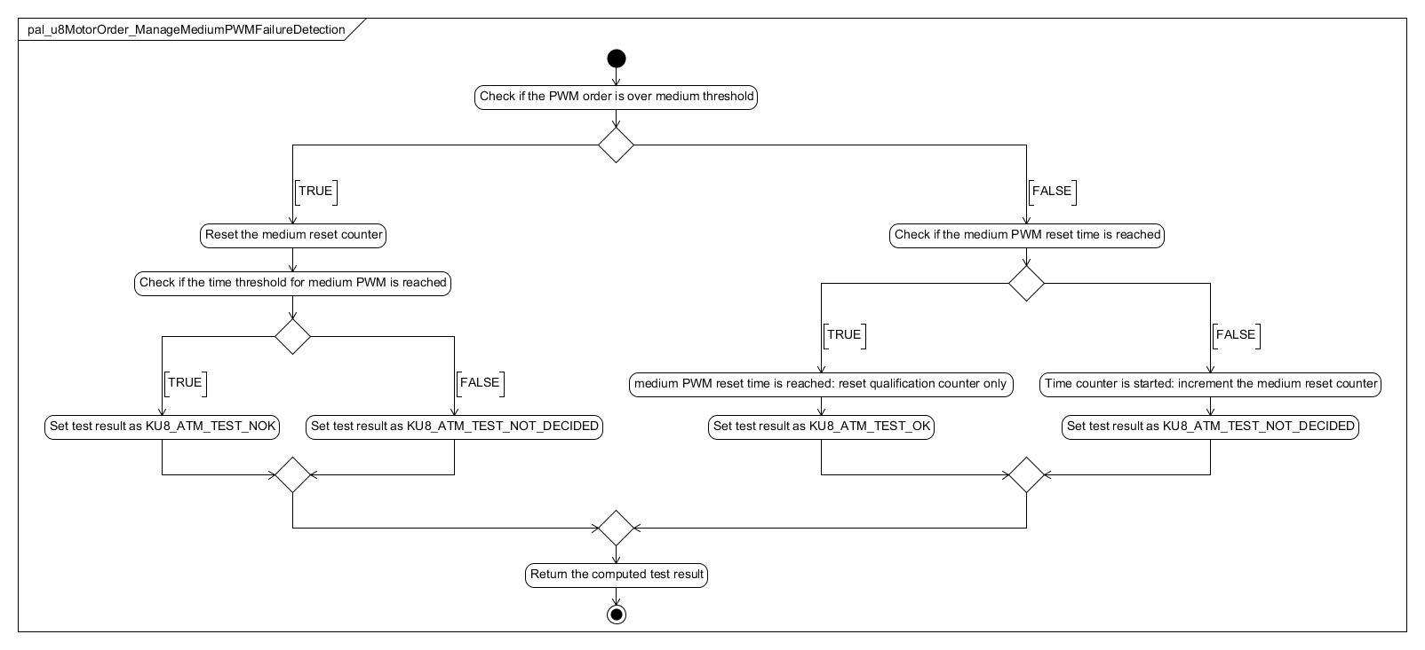

Figure pal_u8MotorOrder_ManageMediumPWMFailureDetection

### pal_u8MotorOrder_ManageHighPWMFailureDetection

|  |  |  |
| --- | --- | --- |
| Object | | |
| This function aims at manage a time counter and a reset counter to detect if the PWM order has been over a "high current threshold" for more than the associated "high current time threshold", since the last time the PWM order was continuously under or equal to the "high current threshold" for a "high current reset time threshold". | | |
| **Prototype** | | |
| LOCAL uint8 pal_u8MotorOrder_ManageHighPWMFailureDetection (const uint8 ku8AbsoluteValue_MotorPWMOrder_Percent) | | |
| **Input parameters** | | |
| Name | Type | Description |
| ku8AbsoluteValue_MotorPWMOrder_Percent | const uint8 | Motor Pwm value |
| **Output parameters** | | |
| Name | Type | Description |
| NA | NA | NA |
| **Return value** | | |
| Type | Description | |
| uint8 | The result value on uint8 with the ATM return value | |
| **Dynamic aspect** | | |
| Who(callers) | Description | |
| PAL_Autotest_CheckMotorPowerOrder | * | |
| **Static aspect** | | |
|  | | |
| **Constrains** | | |
|  | | |
|  |  |  |

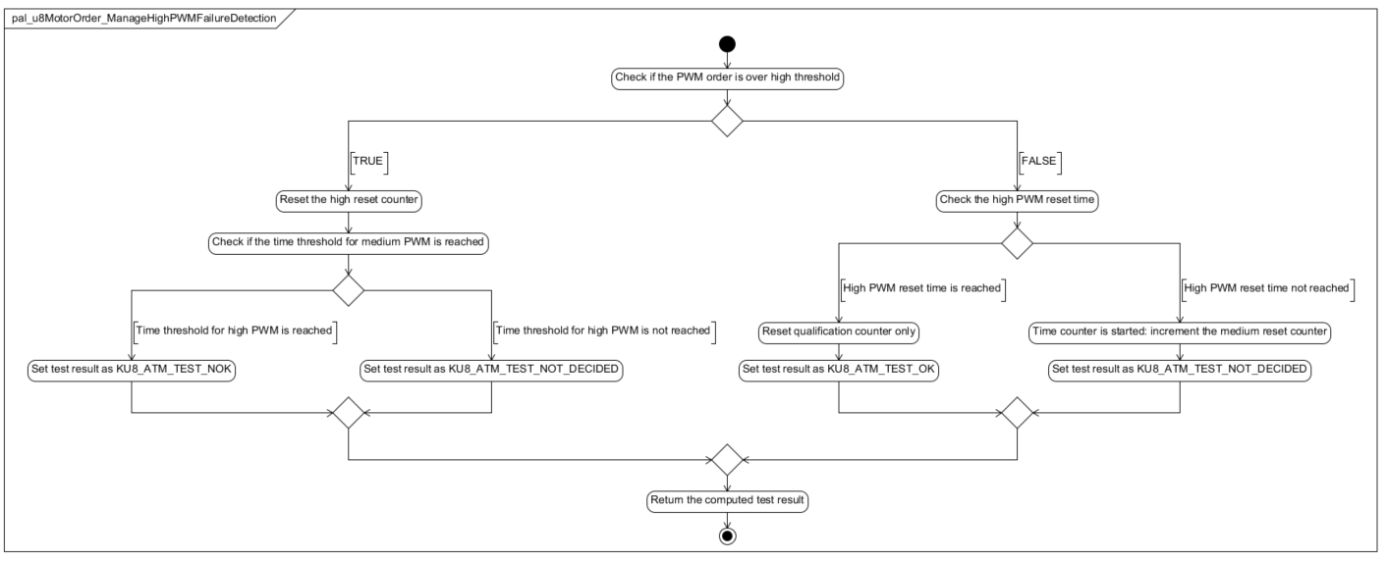

Figure pal_u8MotorOrder_ManageHighPWMFailureDetection

### pal_HighSideSWRegFreeWheelingPhase

|  |  |  |
| --- | --- | --- |
| Object | | |
| This function is called in case of a failed occurrence of HS SW auto test | | |
| **Prototype** | | |
| LOCAL void pal_HighSideSWRegFreeWheelingPhase (void) | | |
| **Input parameters** | | |
| Name | Type | Description |
| NA | NA | NA |
| **Output parameters** | | |
| Name | Type | Description |
| NA | NA | NA |
| **Return value** | | |
| Type | Description | |
| NA | - | |
| **Dynamic aspect** | | |
| Who(callers) | Description | |
| PAL_Autotest_CheckHighSideSwRegulation | * | |
| **Static aspect** | | |
|  | | |
| **Constrains** | | |
|  | | |
|  |  |  |
|  |  |  |

### pal_u8HighSideSWRegStep_1

|  |  |  |
| --- | --- | --- |
| Object | | |
| This function has to manage the step 1 for HS SW auto test | | |
| **Prototype** | | |
| LOCAL uint8 pal_u8HighSideSWRegStep_1 (void) | | |
| **Input parameters** | | |
| Name | Type | Description |
| NA | NA | NA |
| **Output parameters** | | |
| Name | Type | Description |
| NA | NA | NA |
| **Return value** | | |
| Type | Description | |
| uint8 | The test result | |
| **Dynamic aspect** | | |
| Who(callers) | Description | |
| PAL_Autotest_CheckHighSideSwRegulation | * | |
| **Static aspect** | | |
|  | | |
| **Constrains** | | |
|  | | |
|  |  |  |
|  |  |  |

### pal_u8HighSideSWRegStep_2

|  |  |  |
| --- | --- | --- |
| Object | | |
| This function has to manage the step 2 for HS SW auto test | | |
| **Prototype** | | |
| LOCAL uint8 pal_u8HighSideSWRegStep_2 (void) | | |
| **Input parameters** | | |
| Name | Type | Description |
| NA | NA | NA |
| **Output parameters** | | |
| Name | Type | Description |
| NA | NA | NA |
| **Return value** | | |
| Type | Description | |
| uint8 | The test result | |
| **Dynamic aspect** | | |
| Who(callers) | Description | |
| PAL_Autotest_CheckHighSideSwRegulation | * | |
| **Static aspect** | | |
|  | | |
| **Constrains** | | |
|  | | |
|  |  |  |
|  |  |  |

## Types

### PAL_tHBridgeDefinition

|  |  |  |
| --- | --- | --- |
| **Field Name** | **Field Type** | **Field description** |
| u16LinarSlopeDutyCycle | uint16 | Linear Slope Duty Cycle |
| s16LinarOffsetDutyCycle | sint16 | Linear Offset Duty Cycle |
| u16IdleDutyCycleLevel | uint16 | Idle Duty Cycle Level |
| u16ReadEnableDioId | uint16 | Read Enable Dio Id |
| u16DriveEnableDioId | uint16 | Drive Enable Dio Id |
| u8PwmChannelId | uint8 | Pwm Channel Id |

### PAL_tHBridgeCurrentValues

|  |  |  |
| --- | --- | --- |
| **Field Name** | **Field Type** | **Field description** |
| u32SlopeToApplyNumerator | uint32 | Slope To Apply Numerator |
| s32OffsetToApplyNumerator | sint32 | Offset To Apply Numerator |
| s16RawDutyCycleCommand | sint16 | Raw Duty Cycle Command |
| s16AdaptedDutyCycleCommand | sint16 | Adapted Duty Cycle Command |
| u8EnableCommand | uint8 | Enable Command |
| bIsPwrStgInSelfProtection | boolean | Driver Is PwrStg In Self Protection |

### PAL_tBoostDriverDefinition

|  |  |  |
| --- | --- | --- |
| **Field Name** | **Field Type** | **Field description** |
| u16IdleDutyCycleLevel | uint16 | Idle Duty Cycle Level |
| u8PwmChannelId | uint8 | Pwm Channel Id |
| u8PwmCPChannelId | uint8 | Pwm CP Channel Id |
| u8DioChannelHighId | uint16 | Dio Channel High Id |
| u8DioChannelLowId | uint16 | Dio Channel Low Id |

### PAL_tFullBridgeDefinition

|  |  |  |
| --- | --- | --- |
| **Field Name** | **Field Type** | **Field description** |
| u16LinarSlopeNumDutyCycle | uint16 | Linear Slope Num Duty Cycle |
| u16LinarSlopeDenDutyCycle | uint16 | Linear Slope Den Duty Cycle |
| u16LinarOffsetNumDutyCycle | uint16 | Linear Offset Num Duty Cycle |
| u16LinarOffsetDenDutyCycle | uint16 | Linear Offset Den Duty Cycle |
| u16IdleDutyCycleLevel | uint16 | Idle Duty Cycle Level |
| u16ReadEnableDioId | uint16 | Read Enable Dio Id |
| u16DriveEnableDioId | uint16 | Drive Enable Dio Id |
| u8DirectionDioId | uint8 | Direction Dio Id |
| u8PwmChannelId | uint8 | Pwm Channel Id |

### PAL_tPrelBoostTestData

|  |  |  |
| --- | --- | --- |
| **Field Name** | **Field Type** | **Field description** |
| u16PreBoostDeadTimeCounter | uint16 | Pre Boost Dead Time Counter |
| u8PreliminaryBoostTestState | uint8 | Preliminary Boost Test State |
| u8PreBoostStep1State | uint8 | Pre Boost Step 1 State |
| u8PreBoostStep2State | uint8 | Pre Boost Step 2 State |
| u8PreBoostStep3State | uint8 | Pre Boost Step 3 State |
| u8PreBoostStep4State | uint8 | Pre Boost Step 4 State |
| u8PreBoostNbTries | uint8 | Pre Boost Number of Tries |
| u8PreBoostStep1ChargeCounter | uint8 | Pre Boost Step 1 Charge Counter |
| u8PreBoostStep1DischargeCounter | uint8 | Pre Boost Step 1 Discharge Counter |

### PAL_tVBoostTestData

|  |  |  |
| --- | --- | --- |
| **Field Name** | **Field Type** | **Field description** |
| u16BoostStep1VPMotorStart | uint16 | Boost Step 1 VP Motor Start |
| u16DeadTimeCounter | uint16 | Dead Time Counter |
| u8BoostTestState | uint8 | Boost Test State |
| u8BoostStep1State | uint8 | Boost Step 1 State |
| u8BoostStep2State | uint8 | Boost Step 2 State |
| u8BoostStep1StateMachineCounter | uint8 | Boost Step 1 State Machine Counter |
| u8BoostStep2StateMachineCounter | uint8 | Boost Step 2 State Machine Counter |
| u8BoostNbrOfTryCounter | uint8 | Boost Number Of Try Counter |
| u8BoostBatteryConditions | uint8 | Boost Battery Conditions |
| u8LostBatteryConditionsCounter | uint8 | Lost Battery Conditions Counter |

### PAL_tAutoTestData

|  |  |  |
| --- | --- | --- |
| **Field Name** | **Field Type** | **Field description** |
| stPreliminaryBoostData | PAL_tPrelBoostTestData | Preliminary Boost Data |
| stVboostData | PAL_tVBoostTestData | Vboost Data |
| u32MotorOrderMediumThrsTimeCounter | uint32 | Motor Order Medium Thrs Time Counter |
| u32MotorCurrentMediumThrsTimeCounter | uint32 | Motor Current Medium Thrs Time Counter |
| u16HighSideSw_DeadTimeCounter | uint16 | High Side Sw Dead Time Counter |
| u16MotorOrderMediumThrsTimeResetCounter | uint16 | Motor Order Medium Thrs Time Reset Counter |
| u16MotorCurrentMediumThrsTimeResetCounter | uint16 | Motor Current Medium Thrs Time Reset Counter |
| u16MotorOrderHighThrsTimeCounter | uint16 | Motor Order High Thrs Time Counter |
| u16MotorCurrentHighThrsTimeCounter | uint16 | Motor Current High Thrs Time Counter |
| u16MotorOrderHighThrsTimeResetCounter | uint16 | Motor Order High Thrs Time Reset Counter |
| u16MotorCurrentHighThrsTimeResetCounter | uint16 | Motor Current High Thrs Time Reset Counter |
| u16MotorOrderErrorResetTimeCounter | uint16 | Motor Order Error Reset Time Counter |
| u16MotorCurrentErrorResetTimeCounter | uint16 | Motor Current Error Reset Time Counter |
| u8PowerOrderExecutedCycleMemory | uint8 | Power Order Executed Cycle Memory |
| u8PowerCurrentExecutedCycleMemory | uint8 | Power Current Executed Cycle Memory |
| u8MosfetOC_State | uint8 | Mosfet OC State |
| u8MosfetOC_NbTries | uint8 | Mosfet OC Number of Tries |
| u8MotorBlockedFailedCntr | uint8 | Motor Blocked Failed Counter |
| u8MotorBlockedPassedCntr | uint8 | Motor Blocked Passed Counter |
| u8MotorSCFailedCntr | uint8 | Motor SC Failed Counter |
| u8MotorSCPassedCntr | uint8 | Motor SC Passed Counter |
| u8HighSideSw_TestState | uint8 | High Side Sw Test State |
| u8HighSideSw_NbTries | uint8 | High Side Sw Number of Tries |
| u8HighSideSw_FreeWheelingTimer | uint8 | High Side Sw Free Wheeling Timer |

### PAL_tTopologyConfiguration

|  |  |  |
| --- | --- | --- |
| **Field Name** | **Field Type** | **Field description** |
| stHBridgeDef | PAL_tHBridgeDefinition | H-Bridge Definition |
| stBoosterDef | PAL_tBoostDriverDefinition | Booster Definition |
| stFullBridgeDef | PAL_tFullBridgeDefinition | Full Bridge Definition |

## Variables

### PAL_kstHardWareTopology

|  |  |  |
| --- | --- | --- |
| Type | Value |  |
| PAL_tTopologyConfiguration | N.A. | |
| **Description** | | |
| Hardware topology used by ECU | | |
| **Definition** | | |
| const PAL_tTopologyConfiguration | | |

### PAL_u8RequestedMode

|  |  |  |
| --- | --- | --- |
| Type | Value |  |
| uint8 | N.A. | |
| **Description** | | |
| Global data used to set the state machine status for the PAL component | | |
| **Definition** | | |
| static uint8 PAL_u8RequestedMode | | |

### PAL_u8ModeState

|  |  |  |
| --- | --- | --- |
| Type | Value |  |
| uint8 | N.A. | |
| **Description** | | |
| Global data used to know the state machine status for the PAL component | | |
| **Definition** | | |
| uint8 PAL_u8ModeState | | |

### PAL_u8FreeWheelingTimer

|  |  |  |
| --- | --- | --- |
| Type | Value |  |
| uint8 | N.A. | |
| **Description** | | |
| Timer used to set the state machine status for the PAL component | | |
| **Definition** | | |
| uint8 PAL_u8FreeWheelingTimer | | |

### PAL_Cfg_InternalData

|  |  |  |
| --- | --- | --- |
| Type | Value |  |
| PAL_tHBridgeCurrentValues | N.A. | |
| **Description** | | |
| This variable is used to store static data | | |
| **Definition** | | |
| PAL_tHBridgeCurrentValues PAL_Cfg_InternalData | | |

### PAL_Cfg_AT_InternalData

|  |  |  |
| --- | --- | --- |
| Type | Value |  |
| PAL_tAutoTestData | N.A. | |
| **Description** | | |
| This variable is used to store autotests data | | |
| **Definition** | | |
| PAL_tAutoTestData PAL_Cfg_AT_InternalData | | |

## Constants

### PAL_CFG_TOPO_HBRIDGE_NB

|  |  |
| --- | --- |
| Name | Value |
| H-Bridge number | 2 |
| **Definition** | |
| #define PAL_CFG_TOPO_HBRIDGE_NB | |
| **Description** | |
| Number of the H-Bridges | |

### PAL_CFG_KU8_HB_P_ID

|  |  |
| --- | --- |
| Name | Value |
| H-Bridge P Id | 0 |
| **Definition** | |
| #define PAL_CFG_KU8_HB_P_ID | |
| **Description** | |
| ID for the first H-Bridge (P) | |

### PAL_CFG_KU8_HB_N_ID

|  |  |
| --- | --- |
| Name | Value |
| H-Bridge N Id | 1 |
| **Definition** | |
| #define PAL_CFG_KU8_HB_N_ID | |
| **Description** | |
| ID for the second H-Bridge (N) | |

### PAL_CFG_TOPO_SHUNT_NB

|  |  |
| --- | --- |
| Name | Value |
| Shunt number | 0 |
| **Definition** | |
| #define PAL_CFG_TOPO_SHUNT_NB | |
| **Description** | |
| Macro to enable/disable the booster function | |

### PAL_CFG_TOPO_FULL_BRIDGE_NB

|  |  |
| --- | --- |
| Name | Value |
| Full bridge number | 0 |
| **Definition** | |
| #define PAL_CFG_TOPO_FULL_BRIDGE_NB | |
| **Description** | |
| Macro to enable/disable the booster function | |

### PAL_CFG_FREEWHEELING_TIME

|  |  |
| --- | --- |
| Name | Value |
| Freewheeling time | 100 |
| **Definition** | |
| #define PAL_CFG_FREEWHEELING_TIME | |
| **Description** | |
| Configuration time for the freewheeling functionality | |

### PAL_CFG_PERIODIC_FCT_CALL

|  |  |
| --- | --- |
| Name | Value |
| Period function call | 2 |
| **Definition** | |
| #define PAL_CFG_PERIODIC_FCT_CALL | |
| **Description** | |
| Periodicity of the main function (in ms) | |

### PAL_CFG_HIGH_LIMIT_LLD_CMD

|  |  |
| --- | --- |
| Name | Value |
| High limit LLD Command | 0x8000 |
| **Definition** | |
| #define PAL_CFG_HIGH_LIMIT_LLD_CMD | |
| **Description** | |
| Output limits for duty cycle values sent to PWM driver | |

### PAL_CFG_DUTY_CYCLE_ADAPT_DEN

|  |  |
| --- | --- |
| Name | Value |
| Configured Duty Cycle DEN adapt | 625 |
| **Definition** | |
| #define PAL_CFG_DUTY_CYCLE_ADAPT_DEN | |
| **Description** | |
| Constant value used to adapt duty cycle to HW constraints | |

### PAL_CFG_DUTY_CYCLE_ADAPT_ROUND

|  |  |
| --- | --- |
| Name | Value |
| Configured Duty Cycle round adapt | 312 |
| **Definition** | |
| #define PAL_CFG_DUTY_CYCLE_ADAPT_ROUND | |
| **Description** | |
| Constant value used to adapt duty cycle to HW constraints | |

### PAL_CFG_DUTY_CYCLE_ADAPT_A_NUM

|  |  |
| --- | --- |
| Name | Value |
| Configured Duty Cycle A Number adapt | 32 |
| **Definition** | |
| #define PAL_CFG_DUTY_CYCLE_ADAPT_A_NUM | |
| **Description** | |
| Constant value used to adapt duty cycle to HW constraints | |

### PAL_CFG_DUTY_CYCLE_ADAPT_B_NUM

|  |  |
| --- | --- |
| Name | Value |
| Configured Duty Cycle B Number adapt | 2048 |
| **Definition** | |
| #define PAL_CFG_DUTY_CYCLE_ADAPT_B_NUM | |
| **Description** | |
| Constant value used to adapt duty cycle to HW constraints | |

### PAL_CFG_SLOPE_CTRL_MAX_VALUE

|  |  |
| --- | --- |
| Name | Value |
| Configured Slope control maximum value | 200 |
| **Definition** | |
| #define PAL_CFG_SLOPE_CTRL_MAX_VALUE | |
| **Description** | |
| Constant value used to adapt duty cycle to HW constraints | |

### PAL_CFG_SLOPE_DEFAULT_VALUE

|  |  |
| --- | --- |
| Name | Value |
| Configured Slope default value | 100 |
| **Definition** | |
| #define PAL_CFG_SLOPE_DEFAULT_VALUE | |
| **Description** | |
| Constant value used to adapt duty cycle to HW constraints | |

### PAL_CFG_OFFSET_CTRL_MAX_VALUE

|  |  |
| --- | --- |
| Name | Value |
| Configured Control Offset maximum value | 10000 |
| **Definition** | |
| #define PAL_CFG_OFFSET_CTRL_MAX_VALUE | |
| **Description** | |
| Constant value used to adapt duty cycle to HW constraints | |

### PAL_CFG_OFFSET_CTRL_MIN_VALUE

|  |  |
| --- | --- |
| Name | Value |
| Configured Control Offset minimum value | -10000 |
| **Definition** | |
| #define PAL_CFG_OFFSET_CTRL_MIN_VALUE | |
| **Description** | |
| Constant value used to adapt duty cycle to HW constraints | |

### PAL_CFG_OFFSET_DEFAULT_VALUE

|  |  |
| --- | --- |
| Name | Value |
| Configured Offset default value | 0 |
| **Definition** | |
| #define PAL_CFG_OFFSET_DEFAULT_VALUE | |
| **Description** | |
| Constant value used to adapt duty cycle to HW constraints | |

### KU8_NB_INTERP_PTS_HB_CALIB

|  |  |
| --- | --- |
| Name | Value |
| Interp. Points Half-Bridge calibration | 5 |
| **Definition** | |
| #define KU8_NB_INTERP_PTS_HB_CALIB | |
| **Description** | |
| Constant value used in H-Bridge calibration | |

### PAL_KU8_INIT_MODE_STATE

|  |  |
| --- | --- |
| Name | Value |
| Init Mode State | 0x00 |
| **Definition** | |
| #define PAL_KU8_INIT_MODE_STATE | |
| **Description** | |
| Mask used to store the state machine status for PAL component | |

### PAL_KU8_DIAGNOSTIC_MODE_STATE

|  |  |
| --- | --- |
| Name | Value |
| Diagnostic Mode State | 0x01 |
| **Definition** | |
| #define PAL_KU8_DIAGNOSTIC_MODE_STATE | |
| **Description** | |
| Mask used to store the state machine status for PAL component | |

### PAL_KU8_IDLE_MODE_STATE

|  |  |
| --- | --- |
| Name | Value |
| Idle Mode State | 0x02 |
| **Definition** | |
| #define PAL_KU8_IDLE_MODE_STATE | |
| **Description** | |
| Mask used to store the state machine status for PAL component | |

### PAL_KU8_ACTIVATION_MODE_STATE

|  |  |
| --- | --- |
| Name | Value |
| Activation Mode State | 0x04 |
| **Definition** | |
| #define PAL_KU8_ACTIVATION_MODE_STATE | |
| **Description** | |
| Mask used to store the state machine status for PAL component | |

### PAL_KU8_OFF_MODE_STATE

|  |  |
| --- | --- |
| Name | Value |
| Off Mode State | 0x08 |
| **Definition** | |
| #define PAL_KU8_OFF_MODE_STATE | |
| **Description** | |
| Mask used to store the state machine status for PAL component | |

### PAL_KU16_MAX_ADC_VALUE

|  |  |
| --- | --- |
| Name | Value |
| Maximum ADC value | 1024 |
| **Definition** | |
| #define PAL_KU16_MAX_ADC_VALUE | |
| **Description** | |
| Maximum threshold for ADC value | |

### PAL_KU16_MAX_ANALOG_CH_VALUE

|  |  |
| --- | --- |
| Name | Value |
| Maximum Analog Channel Value | 5000 |
| **Definition** | |
| #define PAL_KU16_MAX_ANALOG_CH_VALUE | |
| **Description** | |
| Maximum voltage (mV) that can be measured directly by the ADC | |

### PAL_KU16_DEFAULT_HW_SELF_PROT_THRS

|  |  |
| --- | --- |
| Name | Value |
| Default HW Self Protection Threshold | 819 |
| **Definition** | |
| #define PAL_KU16_DEFAULT_HW_SELF_PROT_THRS | |
| **Description** | |
| Default value (in absolute number) for the threshold used in HW Self Protection AT | |

### PAL_KU32_CONVERT_A_TO_MA

|  |  |
| --- | --- |
| Name | Value |
| Convert Ampere to milli Ampere | 1000 |
| **Definition** | |
| #define PAL_KU32_CONVERT_A_TO_MA | |
| **Description** | |
| Macro to convert Ampere in milli Ampere | |

### PAL_KU8_PERIODICITY_10_MS

|  |  |
| --- | --- |
| Name | Value |
| 10 ms Periodicity | 10 |
| **Definition** | |
| #define PAL_KU8_PERIODICITY_10_MS | |
| **Description** | |
| Periodicity of the Motor Current AT | |

### PAL_KU8_CONVERT_CENTIAMP_TO_MILLIAMP

|  |  |
| --- | --- |
| Name | Value |
| Convert centi Ampere to milli Ampere | 10 |
| **Definition** | |
| #define PAL_KU8_CONVERT_CENTIAMP_TO_MILLIAMP | |
| **Description** | |
| Macro to convert centi Ampere in milli Ampere | |

### PAL_S32_CONVERT_A_TO_MA

|  |  |
| --- | --- |
| Name | Value |
| Convert Ampere to milli Ampere | 1000 |
| **Definition** | |
| #define PAL_KU32_CONVERT_A_TO_MA | |
| **Description** | |
| Macro to convert Ampere in milli Ampere | |

### PAL_KU8_OCAT_PREPARE_STEP_1

|  |  |
| --- | --- |
| Name | Value |
| Used for MOSFET Open Circuit state machine | 1 |
| **Definition** | |
| #define PAL_KU8_OCAT_PREPARE_STEP_1 | |
| **Description** | |
| Macro used for MOSFET Open Circuit state machine | |

### PAL_KU8_OCAT_EXECUTE_STEP_1_PREPARE_STEP_2

|  |  |
| --- | --- |
| Name | Value |
| Used for MOSFET Open Circuit state machine | 2 |
| **Definition** | |
| #define PAL_KU8_OCAT_EXECUTE_STEP_1_PREPARE_STEP_2 | |
| **Description** | |
| Macro used for MOSFET Open Circuit state machine | |

### PAL_KU8_OCAT_EXECUTE_STEP_2_PREPARE_STEP_3

|  |  |
| --- | --- |
| Name | Value |
| Used for MOSFET Open Circuit state machine | 3 |
| **Definition** | |
| #define PAL_KU8_OCAT_EXECUTE_STEP_2_PREPARE_STEP_3 | |
| **Description** | |
| Macro used for MOSFET Open Circuit state machine | |

### PAL_KU8_OCAT_EXECUTE_STEP_3_PREPARE_STEP_4

|  |  |
| --- | --- |
| Name | Value |
| Used for MOSFET Open Circuit state machine | 4 |
| **Definition** | |
| #define PAL_KU8_OCAT_EXECUTE_STEP_3_PREPARE_STEP_4 | |
| **Description** | |
| Macro used for MOSFET Open Circuit state machine | |

### PAL_KU8_OCAT_EXECUTE_STEP_4

|  |  |
| --- | --- |
| Name | Value |
| Used for MOSFET Open Circuit state machine | 5 |
| **Definition** | |
| #define PAL_KU8_OCAT_EXECUTE_STEP_4 | |
| **Description** | |
| Macro used for MOSFET Open Circuit state machine | |

### PAL_KU8_EIGHTY

|  |  |
| --- | --- |
| Name | Value |
| Motor disengagement auto-test parameter | 80 |
| **Definition** | |
| #define PAL_KU8_EIGHTY | |
| **Description** | |
| Macro used for Motor disengagement auto-test | |

### PAL_KU8_DIVIDE_BY_64_RIGHT_SHIFT

|  |  |
| --- | --- |
| Name | Value |
| Motor disengagement auto-test parameter | 6 |
| **Definition** | |
| #define PAL_KU8_DIVIDE_BY_64_RIGHT_SHIFT | |
| **Description** | |
| Macro used for Motor disengagement auto-test | |

### PAL_KU8_CONVERT_IN_PERCENT

|  |  |
| --- | --- |
| Name | Value |
| Motor disengagement auto-test parameter | 100 |
| **Definition** | |
| #define PAL_KU8_DIVIDE_BY_64_RIGHT_SHIFT | |
| **Description** | |
| Macro used for Motor disengagement auto-test | |

### PAL_KU32_CONVERT_MS_TO_100_MS

|  |  |
| --- | --- |
| Name | Value |
| 100ms periodicity | 100 |
| **Definition** | |
| #define PAL_KU32_CONVERT_MS_TO_100_MS | |
| **Description** | |
| Macro used for Motor disengagement auto-test | |

### PAL_KU32_SIXTEEN

|  |  |
| --- | --- |
| Name | Value |
| Motor Short Circuit autotest parameter | 16 |
| **Definition** | |
| #define PAL_KU32_SIXTEEN | |
| **Description** | |
| Macro used for Motor Short Circuit autotest | |

### PAL_KU8_MOTOR_SHORT_CIRCUIT_RESITANCE_MIN_IDX

|  |  |
| --- | --- |
| Name | Value |
| Select the minimum resistance from the related NVM parameters | 0 |
| **Definition** | |
| #define PAL_KU8_MOTOR_SHORT_CIRCUIT_RESITANCE_MIN_IDX | |
| **Description** | |
| Macro used to select the minimum resistance from the related NVM parameters | |

### PAL_KU8_CONVERT_DUTY_CYCLE_TO_PWM_ORDER_FACTOR

|  |  |
| --- | --- |
| Name | Value |
| used to convert a duty cycle into PWM order | 64 |
| **Definition** | |
| #define PAL_KU8_CONVERT_DUTY_CYCLE_TO_PWM_ORDER_FACTOR | |
| **Description** | |
| Macro used to convert a duty cycle into PWM order | |

### PAL_KU8_HIGH_SIDE_SW_REG_INIT

|  |  |
| --- | --- |
| Name | Value |
| Used for High Side Switch state machine | 0 |
| **Definition** | |
| #define PAL_KU8_HIGH_SIDE_SW_REG_INIT | |
| **Description** | |
| Macro Used for High Side Switch state machine | |

### PAL_KU8_HIGH_SIDE_SW_REG_ACTIVATION_STEP_1

|  |  |
| --- | --- |
| Name | Value |
| Used for High Side Switch state machine | 1 |
| **Definition** | |
| #define PAL_KU8_HIGH_SIDE_SW_REG_ACTIVATION_STEP_1 | |
| **Description** | |
| Macro Used for High Side Switch state machine | |

### PAL_KU8_HIGH_SIDE_SW_REG_ALGO_STEP_2

|  |  |
| --- | --- |
| Name | Value |
| Used for High Side Switch state machine | 2 |
| **Definition** | |
| #define PAL_KU8_HIGH_SIDE_SW_REG_ALGO_STEP_2 | |
| **Description** | |
| Macro Used for High Side Switch state machine | |

### PAL_KU8_HIGH_SIDE_SW_REG_DEAD_TIME

|  |  |
| --- | --- |
| Name | Value |
| Used for High Side Switch state machine | 3 |
| **Definition** | |
| #define PAL_KU8_HIGH_SIDE_SW_REG_DEAD_TIME | |
| **Description** | |
| Macro Used for High Side Switch state machine | |

### PAL_KU8_HIGH_SIDE_SW_REG_FREE_WHEELING_PRESCALER

|  |  |
| --- | --- |
| Name | Value |
| High Side Switch Free wheeling phase parameter | 20 |
| **Definition** | |
| #define PAL_KU8_HIGH_SIDE_SW_REG_FREE_WHEELING_PRESCALER | |
| **Description** | |
| Macro Used for High Side Switch Free wheeling | |

# EEPROM

The EEPROM parameters are all specified in NVP_param config .xls

Refer to this document for more details.

# Configuration

No special configuration for PAL software component.

# Compilation Options

No special configuration for PAL software component.